Om Sri Veera RaghavayaNamaha:

**Editor’s Note**

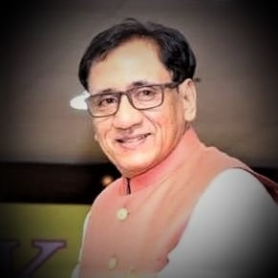

Jyothisa Acharya, Naadi Jyothisa Kesari

**Prof. N. V. R A. Raja, PhD**

M.A. (Astro.), M.A. Phil.), M.Sc (Psy.) PhD. (Astrology), PhD. Vedanga Jyothisa

**Asthana Jyothisa Vidwan, Sri Ahobila Muth, Meena 2 Junior.**

Chairman JKR Astro research Foundation (Regd)

International Vice Chancellor, Yoga Samskrutham University, Florida, USA

101, Rockwell Apts, Road No.6, Jyothi Colony, Kakaguda, secunderabad-15.

Email:astroraja@gmail.com www.astrology training.com

**Dear Readers,**

Jai Meena2

Wishing everyone a very happy and prosperous New Year and Makara Sankranti.

Today is a very auspicious day for every student of Meena2 Naadi system and also to many astro enthusiasts; a plan to launch an e-magazine has come true. Today is Makara Masa, Suklapaksha Poornima and Pushya Nakshatra (Guruji Sri.N.V.Raghavachary’s birth Nakshatra), shows that Guruji is fully blessing everyone.

As you all know there are four main pillars Uttama Drekkana, Nakshatra Digbala, Jeeva and Sareera and Gunas and two sub pillars Binna Pada and Reflection theory in Meena2 Naadi system. There are many hidden secrets in Guruji’s Practical Stellar Astrology (Raghavacharyeam). Many scholars have done research on Practical Stellar Astrology and received doctorates and published their works also. JKR astro research foundation has started in the year 2011 with an only motto to spread Meena2 Naadi System throughout the world and also identify bright scholars, encourage them to do PhD and also to make them speak on the subject in public platform.

In this process we thought of commencing an e magazine which we will be helpful for many astro learners to learn different concepts of this great Meena 2 Naadi System. We are also encouraging thought provoking and research oriented write-ups from JKR and as well as from other parts of the country to contribute articles in English, Tamil, Telugu, Kannada, Malayalam and Hindi.

Many names have come in front of us for this e- magazine, but we selected the name with a combination of light-jyothi-Naadi and astrology and placed before Guruji as Jyothisha is the Chakshu of Vedanga which removes the darkness. Guruji blessed the name of Light of Nadi Astrology, a journal of Meena2 Naadi.

We would like to bring out many hidden secrets of Naadi and put before the world and show how great naadi astrology and easy to use for prediction purposes.

In this first issue, there are many interesting articles on Hayagireeva Stotra, Nakshatra Prasna and Child Birth, Nakshatra Prasna, Marriage matching, Kalamsa Gunas, Nakshatra Digbala, Gurujis 40 Principles etc, and I have also written an article on Mundane Astrology to kindle the interest on the subject linking nakshatras.

A dedicated team is working with me to bring out this e-magazine for the benefit of everyone. I trust you all will support us to spread Nakshatra Sidhantha (Meena2 Naadi Concepts) materialistically and intellectually.

God’s Blessings to all

Prof.NVRA. Raja

Makara Masa- Poornima.

Pushya Nakshatra,Thursday, 28th January,2021.

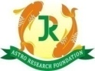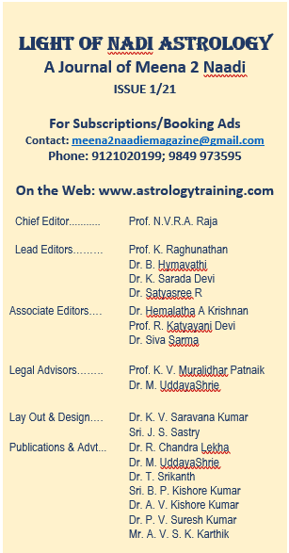

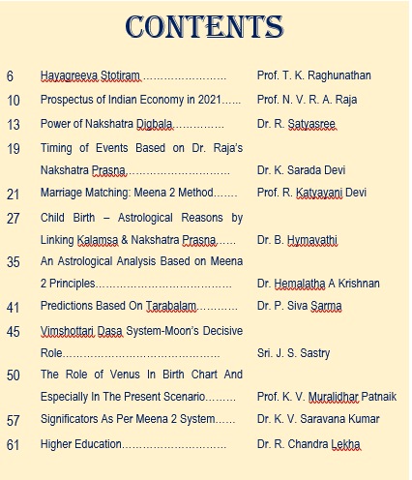

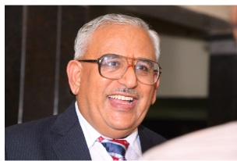

**Dr. B. Venkatakrishna Sastry**

Founder & International Chancellor

Yoga Samskrutham University, Florida, USA

[yogasamskrutham@gmail.com](mailto:yogasamskrutham@gmail.com), [www.ysam.org](http://www.ysam.org)

Namaste Dr. Raja

My hearty congratulations to you and best wishes to your entire team who are dedicated to outreach the total wellness message of Vedanga Jyotisha to the people at large through the digital publication media and different languages.

The goal of Vedic traditions is to spread the message of Sanatana Dharma for right Practice in right way and right time. The benefit of sanatana dharma practice bestows prosperity and total wellness. Guidance from Vedanga Jyothisha and Guruji’s teachings will be well received by the users and practicing community.

In today’s context, digital media has become the global platform to outreach wellness related communications. I am sure that the digital publication with the articles and useful guidance in multiple languages will benefit the user community.

Regards

BVK Sastry

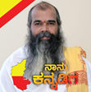 **Dr.Prabhakar K Kashyap,**

**CEO YSAM and Founder Scope,Bangalore**

Dreams and ideas are worthless if they are not backed by the sheer courage to do, congratulation on this big step taken by Dr. Raja to start astrological e-journal. I am so happy and excited for your success. Be proud of your hard work and achievement.

My best wishes for meena2 e journal

Dr. Kashyap

குருஜீ மீனா2

குரு அனுகிரகம் நமக்கு சரியான பாதையில்

நல்அறிவைக் கொடுத்து வழிகாட்டியாக இருக்கும்,

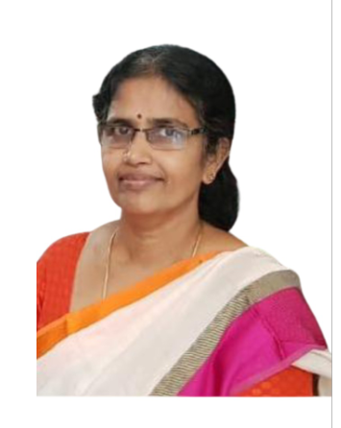

**Dr. R. Vijayalakshmi Ph.D**

HOD Yoga Smaskrutham University,

Chairman, JKR TN Astro Research Foundation,

Barur – 635 201

[barurvijayalakshmi@gmail.com](mailto:barurvijayalakshmi@gmail.com)

www.sriratamilastro.com

_________________________________________________________________

குருஜீ ஸ்ரீஎன்விராகவாச்சாரி மீனா2 அவர்களின் மீனா2 நாடி நட்சத்திர சித்தாந்தம் ஜோதிட முறையில் மின்னஞ்சல் பத்திரிக்கை வெளிவருவதையறிந்து மகிழ்ச்சி, என்னுடைய நீண்ட நாள் கனவு மீன2 நாடி முறை பத்திரிக்கை காண வேண்டுமென்பது. மீனா2 நாடி முறை ஜோதிடத்திற்கு நாம் முதல் தலைமுறை மாணவர்கள். ஆதலால் நமக்கு பொறுப்பும், கடமையும் உள்ளது. குருவின் விதிகளை பொருள் மாறாமல் அடுத்த தலைமுறைக்கு எடுத்துச் செல்ல வேண்டும். மீனா2 நாடி மாணவி என்ற முறையில் இந்த பத்திரிக்கையில் எழுத போகும் அனைத்து மாணவர்களுக்கும் ஒரு வேண்டுகோள், பொருள் அறிந்து,சரியான உதாரண ஜாதகங்களைக் கட்டுரைகள் அனுப்புங்கள். நம்முடைய மீனா2 நாடி முறை உலகெங்கிலும் உள்ள அனைத்து ஜோதிட மாணவர்களும் நன்கு அறிந்துக் கொண்டு பயன்பெற வேண்டும். இந்த பத்திரிக்கைக்கு எழுதும் மற்றும் வேலை செய்யும் அனைவருக்கும் குருஜீஸ்ரீ என்வி ராகவாச்சாரி மீனா2 அவர்களின் ஆசிகள்..

தேதி 28.1.2021 தை பூசம்

இடம் பாரூர்

**HAYAGREEVA STOTIRAM**

* ***PROF. T.K.Raghunathan***

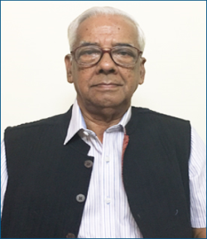

*Prof. T.K.Raghunathan is associated with JKR astro research foundation right from 2011. Presently he is the Principal of our academy. He is a prolific writer combining his spiritual interest and astrology. Two books written by him with titles Prasnotsavam and Tiruppavai were published by JKR astro research foundation. He is also a research supervisor guiding many students both in Vedic and Nakshatra Sidhanta.*

The news about the proposed launch of new E-magazine by JKR Astro research foundation filled me with great pleasure and tremendous urge to be the first contributor of an article has inspired me to prepare this note. It has been a tradition at JKR to start all lessons with invocation of Lord Hayagreeva. In keeping with that tradition, let this article be presented, even though it does not mention anything about astrology in particular. Astrology is a vedangam and represents specialised knowledge. Hayagreeva Swamy is repository of all knowledge including Jyotisham. Hence starting with a note on Hayagreeva is only proper.

Hayagreeva slokam was composed by Nigamantha maha Desikan, also known as Venkatanatha in Sanskrit literature. He was born nearly thousand years ago in a place called Toopul near Kanchi. He was blessed by Lord Hayagreeva in the form of a horse to feed him His Lalaamitam. Desika is regarded as kalidasa of south for the beauty of his writing style. He is respected as one of great acharyas of Vaishnava dharma.

**Hayagreeva stotiram**

// Gnyananandhamayam devam, nirmala sfatikaakritim //

// Aadhaaram sarva vidhyanaam Hayagreevam Upaasmahe //

This is the first of collection of 32 slokams composed by Swami Desika on Lord Hayagreeva, an incarnation by Sriman Narayana, to retrieve knowledge that was snatched away by Asuras, from the custody of Brahma. The Asuras Madhu and kaitaba were confronted by Sriman Narayana in a fierce encounter. Narayana took the form with face of Horse and body of human being and after overwhelming asuras in a battle, restored the knowledge back to its pristine glory. Brahma’s shattered morale was restored as He became once again the custodian of Knowledge by the blessings of Lord with horse face. Sriman Narayana also was hailed as Madhu soodhana.

The first sloka starts with words Gnyanam and Anandham, two essential needs of life. Anandham is a state of mind when the soul is supremely satisfied, fully content. The soul is completely aware of his needs of life, ways of acquiring them and applying them gainfully in life. The ways of meeting the needs would not include coercion, stealth, deceit or over powering any one. The soul is free of tension, and distractions, at peace with himself and world around him.

This state of mind can be realised only when the soul has mastered the knowledge referred here as **GNYANAM.** This knowledge gives the soul ability to distinguish right from wrong, good from bad. This gives ability to do what is right at all times and keep away tendencies that inspire actions of questionable nature. It inspires to share what you have and not covet what others have and you are short of.

The knowledge is the key to achieve the mind set called **Anandham.**

This knowledge is sacred, meant for constructive and development purposes and must be allowed to permeate throughout society unhindered. The knowledge is based on truth, cannot change form or content, and so is permanent. This is what is hailed as Sathyam, Shivam and Sundharam. Not only are these features applicable to knowledge but also its enjoyment as endorsed by the word anandham.

Thus our Lord Sriman Narayan is hailed as Hayagreeva who encompasses all Gnyanam and its Anandham, very suitable for our worship.

We call Him **Devam**. Who is Deva? He is a divine agent. Deva is one who gives, who provides. Our Lord is a Deva because He gives us a soul, body, life, with ability to think and act. He has placed us in a location created by Himself, complete with abundant resources like Air, water, light and food. He has given us an intellect to harness these resources in a right manner. As He has given us right to enjoy, He also has the power to deny and punish those who do not allow use of these resources for common good. The nature that we see all around us is given by him on account of his compassion. So He is Devam.

As a Deva he has got immense power, that is so vast, undecaying and awe inspiring. This awe springs from the abundance of knowledge contained in Him. That Knowledge is, like its creator, everlasting, undecaying and ever expanding but all the time in His full control and stable. That is why He is Deva.

**Nirmalam;** Lord Hayagreeva is described as Nirmalam, meaning that He is devoid of any blemish, stigma, disfigurement, any adulteration or contamination. That is why He is described by Scholars as Sundaram, beautiful to behold. The point to be noted here is that his nirmalatwam comes out of quality of His actions. Freedom from dirt is because he converts dirt into beautiful form as He has done this world.

When you jump in the slush, grime sticks to you. When you indulge in a base act, the stigma remains attached to you. When you associate with people with questionable integrity, questions are raised about you too.

So to be free from all blemishes, you must be right about every one of your actions and this righteousness keeps one clean. Being clean is a divine virtue ever appreciable and ever inspiring.

Our Lord is like that. Nirmalam

**Sfatikam;** He is absolutely transparent, totally clear and correctly seen. Our Lord is pure and good when viewed from any angle. He also looks through everything clearly and without any bias or distortion. That is Akruti or form. Sfatikam is adjective to His form. He is through and through satwik. He can take any form and still be clean and pure like sudhdha sfatikam which means clear as a crystal. Whether he is born as a wild boar, or tortoise or ordinary fish, he is clean and without blemish.

**Adhaaram’** He is the supporter of all knowledge and seekers of knowledge. He supports. He has created our universe by virtue of His vast knowledge. Any edifice can fall apart if it is not based on proper knowledge. That holds good for divinity too. It is stated that He is supporter of all knowledge **adhaaram sarva vidhyaanam**. Vidhya is the result of application of knowledge. A skill is never complete or perfect without purity of knowledge and completeness of its application. Skill is an attribute that generates consistent result and this trait is cultivated with blessings of Hayagreeva. A SKILL THAT IS NOT KNOWLEDGE BASED REMAINS A FLASH IN THE PAN.

This Deva is called **adharam sarva vidhyanaam**. The sages have classified Vidhya in 32 different ways and all knowledge that we see professed by scholars as one or other form of these 32 vidhyas which find their origin in Lord Hayagreeva.

**Hayagreevam;** The actual meaning of this word is horse face. The meaning is more symbolic than actual manifestation. It is a pointer to where the knowledge base is headed.

Horse represents several physical attributes, like speed, power, stamina and perseverance. All these attributes are pre requisites for proper management and application of knowledge. It is no coincidence that western scientists measured power in terms of horse power.

If you scan all our spiritual literature, epics and kavyams, you will find reference to horse only in sacrifices and coronation. There is no mention of any warrior astride a horse in any of our epics. None of the mythological heroes like Rama, Krishna, Arjuna or Skanda are described as riding a horse or fighting on horseback. Yes, Krishna had chariot drawn by five horses. But it is strange; no one was ever sat on top of it. I think, this is where the idea of symbolism gains strength. Man never thought that he had matured enough to boast that he has mastered knowledge. Knowledge was represented by horse. Man had mastered wild animals like tiger, lion, elephant, and birds like eagle, crow and peacock. But mastering and mounting a horse, he did not dare. That is why none of the gods or men from previous yugas mounted a horse. Only in kaliyuga, God is expected to come on horseback flashing a sword.

It is amazing to read from history that civilisation that had warriors fighting on horseback won over civilisation that did not use horses in the battle field. Later on, during 19 and twenty century, the army that boasted of greater horse power in terms of machinery and technology had the winning edge. Thus horse always represented superior knowledge and power.

To my mind, mounting a horse was a perversion of mind that happened in kaliyuga. Man in kaliyuga got too excited with the modicum of success he had gained in his quest for knowledge and his pride peaked. He now thought he had conquered all aspects of knowledge and its management. He mounted the horse and carried on conquering new frontiers. Ever since he has been sliding down on the moral platform and towards self destruction.

Thus Horse represents the epitome of knowledge and our mind conceived a god with a horse face. That God is Hayagreeva.

**Upasmahe;** Let us worship this Lord of knowledge who is pure knowledge and provider of skills, acumen and capability .Let us seek from him that knowledge that will help us to discover our very own hidden strengths and harness them for betterment of not only ourselves but also our community and society at large.

I mentioned about western scientists measuring power in terms of horse power. They also defined power as capacity to do work.. The capacity comes only from knowledge and its proper application. Thus there is no measurable action without power and that power springs only from knowledge and that knowledge is granted to us by Sri Hayagreeva. Let us bow our head at His feet and seek that knowledge.

Jai Meena 2

**PROSPECTS OF INDIAN ECONOMY IN 2021**

* ***Prof. N. V. R A. Raja***



*Jyothisa Acharya, Naadi Jyothisa Kesari (JKR) Prof.N.V.R.A.Raja, popularly known as MEENA 2 JUNIOR is an eminent philosopher, counselor and practicing Astro psychologist for the past 30 years. He did his graduation in science. He is in the mining profession for the past 35 years. He had been appointed as “Asthana Jyothisa Vidwan” of Sri Ahobila Muth by His Holiness 45th Srimath Azhagiya Singar at Ahobilam. He has been into the science*

*of occult for a long time. He had the fortunate guidance of his father Late Sri.N.V.Raghavachary (Meena2) who did 60 years of research in Jyotisha particularly in Stellar Astrology (Naadi). He was drawn to occultism and gradually destined towards astrology. His academic track record includes his successful pursuits of M.A. in Astrology, M.A. in Philosophy and Religion, Post graduate Diploma in Business Management and Ph.D. in Astrology. He has many titles of honor to his credit in the field of astrology. He is also International Vice chancellor of Yoga Samskrutham University Florida, USA.*

Mundane Astrology will play an important role in Vedanga Jyotisha. We may not find many scholars to teach mundane astrology and its intricacies. Our great Rishis Parasara, Varahamira have blessed us with many significant rules and principles to analyse mundane astrology. Here we can use all the three parts of Vedanga Jyotisha namely Hora, Siddantha and Samhita. Once we understand the concept of Sun’s Ingress in Rasi or Sign, Poornima, Amavasya and eclipses, we can easily decode what is in store for a nation or a political party.

**INDIA’S INDEPENDENCE DAY CHART 15-08-1947, 00:00 HRS, NEW DELHI**

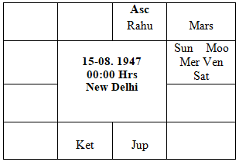

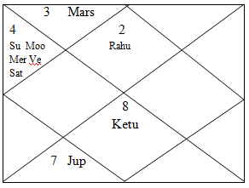

Here, we know Makara Sankranthi day is very important for everyone, on that day, Uttarayana punyakala starts for next 6 months. Relationship with the ascendant of Makara Sankranthi and to India’s Independence Day Ascendant can give many inputs to analyse the prospects of India and Surrounding Countries. Many planets in Makara Sankranthi day in Makara Rasi and also Makara becomes Ascendant at the time Sun entering into Capricorn Sign. The Prospectus of India is going to be very bright for this 2021. Educated Classes, Educational Institutions and those contributing intellectual ideas to the government and to the public will thrive very well. A possibility of a Grand Improvement in Transportation, Communication, Rail Roads we can notice during this year. Possibility of Long-distance Communication connecting through cables and also underwater, Publishing industry that too scientific publications may do very well. Government may divulge many of their plans to improve our economy. Prominent personalities from all over the world may visit India to improve trade and political ties.

Indian Economy is going to boom during this year. Government may effectively utilise lands, neglected farms, minerals, mines etc. Good improvement in administration may happen, business in general, buying and selling may improve considerably. Industries like coal mining, leather products, contractors and builders may utilise their resources very effectively.

**MAKARA SANKRANTHI CHART 14-01-2021, 08:15 HRS, UJJAIN**

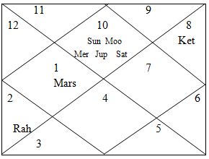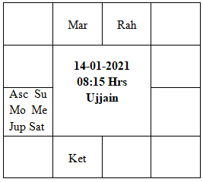

We can notice a great boom in Real Estate, Dam Building and increase in cultivable lands and shipping industry. Already we are noticing a great recovery of automobile industry, this will continue throughout the year. Women in general may contribute in many ways in improving Indian Financial conditions. During this year, we can notice extraordinary agricultural output and also all farmers will be very comfortable. Government may announce many schemes for women welfare, but it may not reach people at right time. Possibility of improvement in Private travel, people may undertake many business and holiday trips. Defense academy may get lot of funds for their development. We can notice a slow improvement in entertainment business, Speculation and Share Market will do very well.

We can notice excellent improvement in public health and also the recent Covax initiation by the Government may reach everyone in a slow manner. Government may keep their warships, warplanes and armaments always keep ready. Expenses on defense areas may mount. All working class, labourers, national employment will be comfortable. Government may bring many reforms to improve economy of the country. Over all prospects of Indian economy will be good. Industries like Automobile, Mining, leather, entertainment and distance mode of teaching may do very well and boost our economy.

During the month of May 2020, I have given the predictions for USA Elections that time predictions given linking eclipse happened in the month of June on USA’s 10th house, whereby I stated that ruling party (Republicans) may not win and any party from Opposition (Democrats) may win the elections, at the time of my predictions the date and name of the candidates for the elections not announced against the Trump. Now we noticed that democrat’s candidate Joe Biden has become president and then ruling party republicans are in trouble in senate. Similarly, about China, I have indicated that there is going to be new virus that may spread in China linking their 8th house. Now we noticed, China is under the reel of a new virus and also many major cities are under lockdown. Watch my online meena2online you tube channel for more analysis on USA and China Prospectus.

Mundane Astrology is a great subject, by focusing our attention towards Sun’s Ingress; we can notice great changes in environment, share market, economy of a Country and political atmosphere.

**----Shubham---**

**//OM SRI VEERARAGHAVAYA NAMAHA//**

**//OM GURUBHYO NAMAHA//**

**POWER OF NAKSHATRA DIGBALA**

* ***DR. Satya Sree R***

*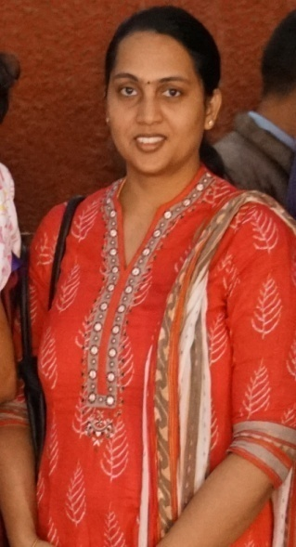Dr.Satyasree is the founder trustee of JKR Astro Research Foundation and granddaughter of Poojya Guruji Sri.N.V.Raghavachary. The author has been awarded with Ph.D. in Vedanga Jyothisha from Yoga Samskrutham University for her research on “Stellar Effects – Nakshatra Digbala and Gunas” based on Meena 2 Naadi principles. She has also completed her M.A in Vedanga Jyothisha from*

*the same university. She also have Post Graduate Diploma in Human Resource Management from Xavier Institute of Management, Bhubaneswar (XIMB) and Bachelor of Engineering in Electrical and Electronics Engineering (EEE) from Vasavi College of Engineering, Secunderabad.*

A planet can gain strength in a number of ways through occupation in a certain sign, own or friendly houses, Bhava, Varga, Paksha. Many classical texts have detailed the sources of strengths of planets. In Nakshatra Siddhantham, one is concerned, mainly, with the power acquired by the Lord of the constellation in which the planet is situated rather than the planet itself. Even when the planet is powerless or not conventionally well-placed in the Zodiac, if its constellation Lord is favourably disposed, then the planet is said to be protected. The main dictum of Meena 2 Nakshatra Siddhantham is “The planet posited in a house may or may not deliver the result, but its star lord will deliver the result favourable or unfavourable.”

Nakshatra Digbala holds a coveted place in Meena 2 Nakshatra Siddhantham and is hailed as one of its pillars. Digbala or Directional strength is the strength derived from planetary directions i.e. their position relative to the kendras or angles in the chart. Varahamihira in BrihatJataka defined Digbala as “Mercury and Jupiter are powerful when in the East or rising sign. The Sun and Mars are powerful when on the South or tenth sign. Saturn is powerful when in the West or setting sign, and the Moon and Venus are powerful when in the North or the 4th sign.” Many of the classical texts agree to the below view for assessment of Digbala in line with Varahamihira.

• Jupiter and Mercury are strong in the Lagna

• Moon and Venus are strong in the 4th house

• Saturn and Rahu are powerful in the 7th house

• Sun, Mars and Ketu are powerful in the 10th house

However, according to Meena Naadi, a planet gains Digbala not only through occupation of the particular kendras mentioned above but also when it gains connection to it in anyway – through stellar lord, conjunction or aspect by the kendra lord. This is termed as Nakshatra Digbala. The rules for ascertaining Digbala of planet are elaborately explained in Dr. Raja’s (Junior Meena 2) works, “Stellar Effects – Jeeva and Sareera” and “Stellar Effects – Nakshatra Prasna”. The reader can refer to these books for further understanding.

Nakshatra Digbala is a powerful yoga in the horoscope and can propel the native to great heights under benefic influence and also boost the Bhavas connected with it. According to Meena 2, “When the planets are well-placed in the constellation with strength, good results ensue even though they are neecha in rasis.” In line with this, a planet posited in its debilitation sign, will not be considered as Neecha, if it is endowed with Nakshatra Digbala. Such is the power of this yoga.

When applying Nakshatra Digbala to predictions, it becomes important to understand when its power is effective. This is the case with any planet which is endowed with power through exaltation or any other source of strength. A powerful planet does not always deliver favourable results as opined by many scholars. If the 6th, 8th or 12th Lords become powerful in a horoscope they might not deliver favourable results as far as material prosperity is concerned. Similarly, if these powerful planets are overwhelmed by the influence of malefics or Dusthanas (6th, 8th and 12th), then they might not deliver beneficial results. When a highly learned scholar visits your house, he may bring good books and toys for your children. On the other hand, when a powerful smuggler visits your house, he may bring unsolicited items and bring in a negative influence on your children. In both the cases, the friend is powerful and delivers results, but it is positive in one case and negative in the other depending on the nature of the person. Likewise, the results provided by the planets gaining Digbala are modified based on the sign, constellation lord and the guna they acquire.

A planet can acquire connection with Bhavas in five ways known as the Pancha Siddhantha philosophy – Sign Lord, Constellation lord, aspect, conjunction and association. The planet gaining Digbala also provides results based on these connections. Of all these factors, the Guna acquired by the planet plays vital role in influencing the nature of results delivered by the planets. This can be understood better with the two charts provided below. In both the cases, the Bhava and karaka are powerful and fortified with Digbala and strength. In one case, this has propelled the native to great prosperity while failing to provide good result in the latter.

**Chart No.1**

Given below is the chart of a native who owns a large chain of jewellers and is the Chairman of many trusts. He owns many properties and leads an affluent life. To enter into the business of jewellery, the 2nd bhava should be rendered strong as it is the primary house of material wealth including jewellery. Venus, the karaka for jewellery, should also be strong.

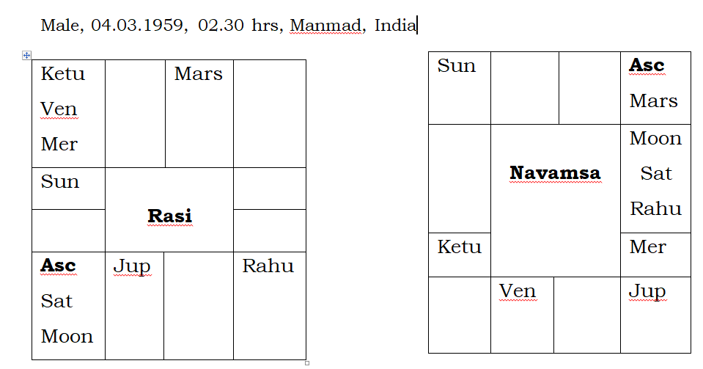

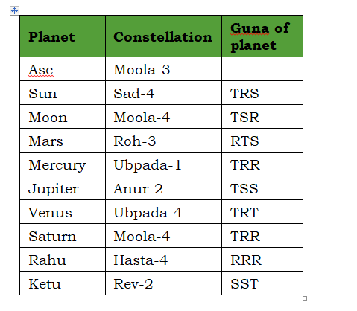

In the above chart, 2nd Lord Saturn is in the star of Ketu which is in conjunction with 7th Lord Mercury. Hence, Saturn possesses Digbala and is in the Guna TRR. Though it has gained Thamasa in the first step, Saturn has become largely Rajasic and has not acquired a good guna. However, the star lord delivers results for a Bhava. 2nd Lord Saturn is in the star of Ketu. Ketu is posited in the 4th house and it is in conjunction with the 10th Lord Mercury. Thus, Ketu gains Digbala. Ketu has acquired the guna SST and thus it has gained Satwica Digbala. It is further in conjunction with Venus and 10th lord Mercury. The combination is being aspected by Lagna Lord Jupiter which is in largely Satwica guna – TSS and also with Digbala as its star lord Saturn is posited in the Lagna. So, Ketu in Satwica Digbala itself is being aspected by Satwica planet Jupiter which is also in Satwica Digbala. Thus, Ketu is dominated by Satwica guna and thus 2nd Bhava flourished through star lord Ketu.

Venus, the karaka for jewellery, is placed in the 4th house and thus it gains Digbala. Though Venus has acquired a largely Thamasic guna in TRT, its star lord, Saturn, is in TRR – largely Rajasic and transfers its guna to Venus. Thus, Venus also gains own guna through its star lord and are powerful with Digbala. Its karakatwas flourished.

Thus, both the 2nd Bhava Lord Saturn and the Karaka Venus have acquired the touch of Rajasic guna and are powerful through Digbala which has endowed great wealth to the native. Also, note that, star lord of 2nd Bhava lord Saturn, Ketu is placed in conjunction with karaka Venus in the 4th house (house of Jupiter) and it is also being aspected by Jupiter. According to Meena 2 principles, “When the constellation lord of a Bhava lord joins with the karaka for that Bhava in an auspicious house, good results are the outcome.” Thus, 2nd Bhava flourished.

**Chart No. 2**

The native of the chart, given below, hails from a poor family. He sells bamboo sieves on the roadside for a living.

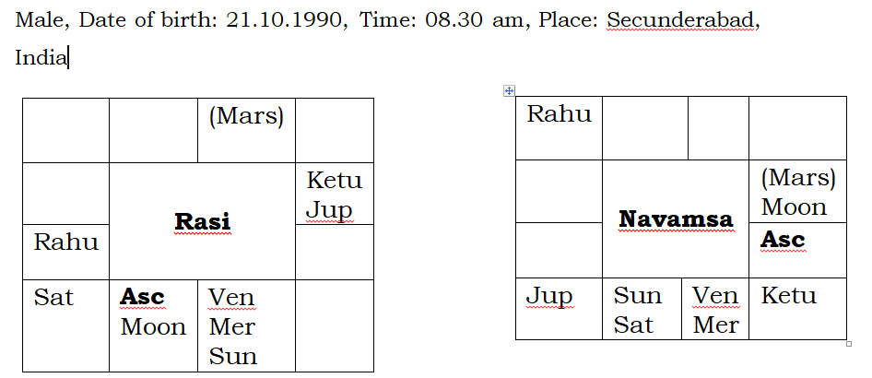

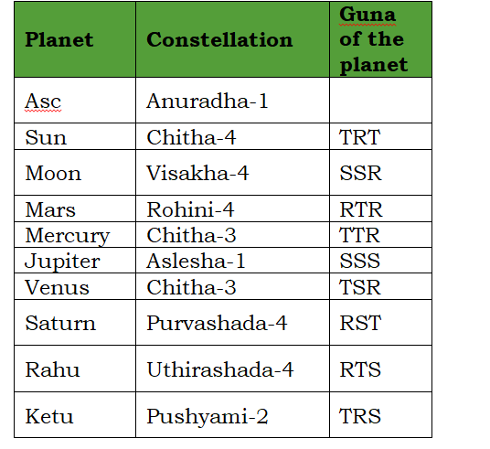

It can be seen in this chart that Dhana karaka and 2nd Lord Jupiter is exalted in the 9th house. Occupant of 2nd house, Saturn is also powerful with Digbala as it is posited in the star of 7th Lord Venus. Despite the strength of Bhava lord, Dhana karaka and the occupant, the native is poor and struggles to make ends meet. Let’s further examine the Bhava and the associated planets.

2nd Lord Jupiter is posited in the star of powerful 8th Lord Mercury which has Thamasa Digbala (TTR). As per Meena 2 Nakshatra Siddhantha, when a Bhava lord is situated in the constellation of a powerful 8th Lord, the Bhava gets spoiled. Even though Jupiter is exalted and in own guna SSS, it is situated in the constellation of a powerful 8th Lord Mercury. Star lord Mercury is also posited in the 12th house with undesirable Thamasic guna, TTR in the first stage and Rajasic guna rendered through inimical Thamasic Mars. Hence, the dhana karaka could not deliver proper result. Also, this powerful Dhanakaraka Jupiter is placed in close conjunction with Ketu and hence gets afflicted. Whenever a powerful benefic comes in close contact with Ketu, it does not deliver the expected results. Additionally, Ketu is in the star of Saturn which is posited in the 2nd house. Hence, Ketu, which has gained connection with the 2nd house, has not allowed Jupiter to deliver results associated with this Bhava.

2nd house occupant Saturn attains Digbala in the star of Venus. Star lord is posited in its own house which is the 12th house in conjunction with a powerful 8th Lord Mercury which has Digbala (Star Lord of Mercury is Lagna Lord Mars). Due to the strong association with 8th Lord Mercury, Venus and thereby Saturn lose their lustre and fail to provide the required result.

10th Bhava and its lord, and karaka Sun are crucial for good profession, and attaining a high status and respect in the society. 10th Lord Sun is in its debilitation sign but still in binapada nakshatra of Mars. However, Rajasic Sun possesses an undesirable guna in the first stage, TRT and it is also in conjunction with powerful 8th Lord Mercury and is posited in the 12th house. Sun has acquired connection with Dusthanas – 8th and 12th houses. Hence, it could not deliver a favourable result and the native does not enjoy a good status in the society.

It can be seen from the charts discussed above that even when the concerned Bhavas and Karakas are fortified with power, they do not always deliver a favourable outcome. In the first chart, the planets gaining Nakshatra Digbala were under benefic influence and favourably placed in the constellations with desirable guna. Hence, they bestowed great wealth and prosperity on the native. However, in the second chart, even an exalted 2nd Lord and Dhana Karaka Jupiter could not help the native due to the overwhelming influence of Dusthanas and malefics on the planet. Thus, before venturing into predictions for powerful planets, it is important to carefully study the situation, connections and especially the guna acquired by the planet as they play an important role in influencing the nature of results.

**//Om Sri Veeraraghavaya Namaha//**

**TIMING OF EVENTS BASED ON DR. RAJA’S NAKSHATRA PRASNA SYSTEM**

* ***Dr.K.Sarada Devi***

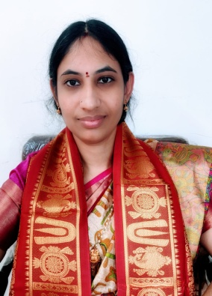

*Dr. Sarada Devi is a professional astrologer. She is a disciple of Dr. NVRA Raja, learned Meena2 Naadi system under his guidance with Guruji NV Raghavachary’s blessings. She is a B. Tech graduate and completed her M.A (Astrology) from Yoga Samskrutham University (Astrology) and also from Telugu University. She has been awarded with PhD for her research on “A Study on Binnapada Concept – Based on Meena 2 Naadi Principles” from Yoga*

*Samskrutham University, Florida, USA. She is also a research supervisor guiding many students and she is the recipient of many astrology titles.*

I am very happy to write an article in the inauguration edition of E-magazine. Our JKR - ARF is conducting NPL quiz through WhatsApp group successfully for the last 3 years. In2020, group was running for almost 5 months up to summer vacation. This year (2021) also Dr. Raja sir wants to conduct NPL quiz to encourage students to master NPL. Announcement regarding this was posted in the group on 14/1/2021 at11:26 A.M.

Out of curiosity, I checked NPL about at what time tomorrow NPL question will posted in NPL quiz groupon17/1/2021at 2:39pm, Hyderabad.

Let us the see the analysis of this question below.

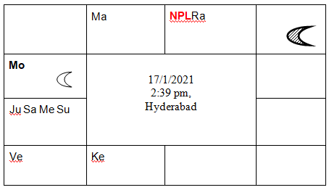

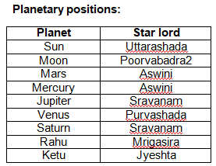

|  |  |  |  |  |
| --- | --- | --- | --- | --- |
| **HRM** | **HRM LORD** | **NPL** | **JEEVA &SAREERA** | **ASSOCIATED PLANETS** |
| Arudra | Rahu | Taurus | Mars & Ketu | - |

At that time DRM is Poorvabhadra 2nd pada which is in Aquarius and HRM is Arudra. Arudra star lord is Rahu. Rahu is posited in Taurus. Now Taurus becomes Dr. Raja’s nakshatra prasna Lagna. Jeeva and sareera planets for HRM lord are Mars and Ketu. Theruling planets are Jupiter, Rahu, Venus, Mars and Ketu.

By posited in Binnapada, DRM will receive aspect of Saturn. HRM is receiving the aspect of 8thoccupant. And NPL lord Venus is posited in8thhouse. The connection of Saturn and 8th house are usually indicating delay. So, we may not expect early posting on 18thJanuary.

Out of all ruling planets Mars is strongest as it is posited in its own house. So, at result time HRM should have a connection with Mars.

In Mrigasira and Chitta HRM we can't expect the result as Mercury doesn't have connection with ruling planets. So, here we are left with two houses Libra and Scorpio.

In Libra HRM will receive the aspect of Mars and when HRM is in Scorpio, it will be in Mars house.

1. But when HRM is in Mars house Scorpio, it will be natural 8thhouseand in fixed sign. Any event having a motto of long run, generally we may not start with fixed sign HRM. So, chances for posting when HRM is in Scorpio are less or almost no.
2. Libra is a movable sign and it will be the 6th house (house of competition) from NPL.Venus is the NPL lord and HRM is aspected by planet venus.So, we can expect the result when HRM is in Libra.

In Libra we have three stars Chitta, Swathi and Visakha. And at question time, Rahu is the HRM lord and Rahu is posited in Lagna with digbala. So, we can expect result in Swathi HRM, 4thpada.

Question was posited in group on 18/1/2021 at 9:20pm in Swathi HRM, 3rd pada.

When we observe

1. HRM at group restart announcement is Uttarabhadra (Saturn=Rahu)

2. HRM at question time is Arudra

3. HRM at question posted time is Swathi

4. DRM at question posted day is Uttarabhadra.

So, we can observe that ruling planet at question time will be the ruling planet at answer time. And HRM at question time will play vital role in giving result.

**//Om Gurubhyonamaha//**

**MARRIAGE MATCHING: MEENA 2 METHOD**

* ***Prof. Ramanujamkathyayani Devi***

*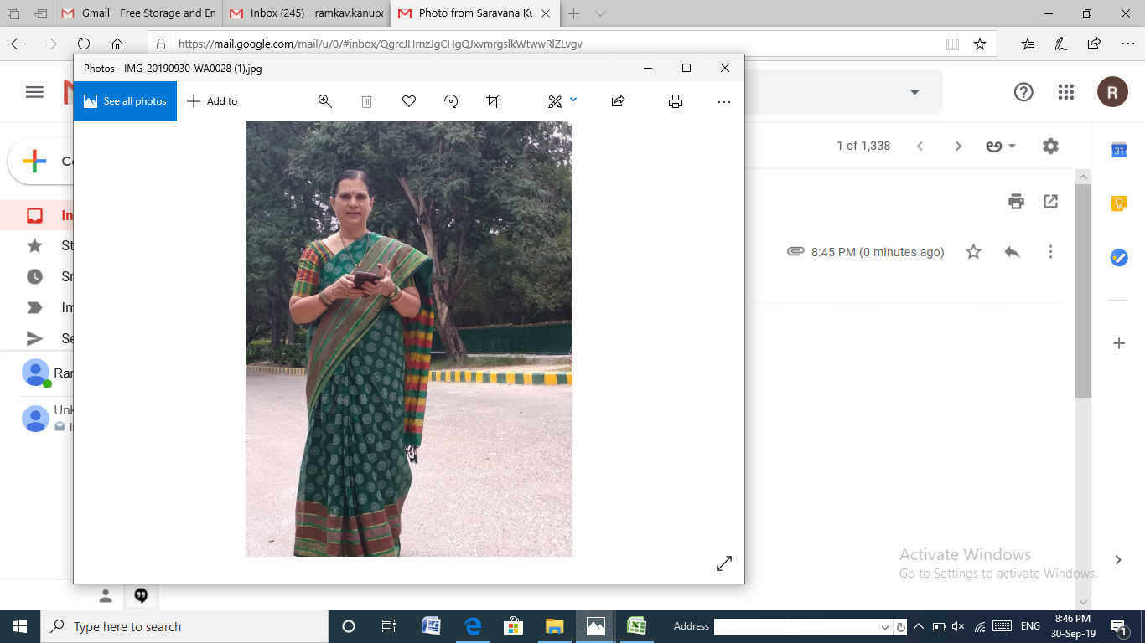Prof. Ramanujam kathyayani Devi is a Professor in Microbiology and completed 33 years of teaching experience. She completed MA Astrology from PSTU in the year 2003_2005 with gold medal. She is Associated with JKR from 2011 till date and senior faculty in JKR. She is awarded with PhD from YSAM Florida in the year 2016 and her thesis topic is PCOD-Stellar perspective. She has 10 paper publications both National Medical journal and one International journal publication in Microbiology. She is the recipient of number of astrology titles.*

With the blessings of my Guruji Prof. N.V.R.A.Raja Sir and Siddhapurusha Paramapujya Shri.N.V.Raghavacharigaru, who unveiled the Naadi secrets in a nut shell. They are the world’s greatest secrets. Matching in Meena -2 method gets easy and accurate.

An attempt has been made to compare the marital concord of couple who were traditionally matched and their life style pattern after comparing with the Meena -2 method.

“MANGALYAM TANTUNANENA MAMA JEEVANA HETHUNA KANTE BHADRAMI SUBHAGE SANJEEVA SHARADAM SHATHAM” .Marriages are made in heaven and consummated on earth. Pairs are made in heaven but marriage is a strong bond between a male and a female who cares, understands, respects each other in every situation of life .Without wife there is no life and without husband there is no wisdom. Marriage is made in heaven but it is our responsibility to make them work in a happy environment.

Man ties a sacred thread around the woman’s neck, while the veda mantras are being chanted, they take an oath to live happily together for many years and remain happy in all walks of life. This divine bond that unites a man and his wife with mutual understanding, attraction, and adjustment acclimatization are vital for happy married life. Little compromise shunning the ego and attitude makes marital life beautiful. Present generation youngsters are adapting to Living relationship and ending in a breakup for such youngsters Meena -2 has right answers to save a marriage and keep the couple happy.

Gotranirnayam; There are various methods the traditionally matched dasavidhaporuthams and we have the Meena -2 method of matching our ancient rishis the Saptharishis and Bharadwaja rishi have identified male lineage of Gotham and said (Gou means cow and trahi means shed) Gotra is like a cow shed protecting the male lineage all the Gotras have evolved from these 8 Gotras only. Biologically the 23 pairs of somatic chromosomes and one pair of sex chromosomes namely the XX from female and XY from male. In XY the Y will suppress the X and this Y is the only one which is transmitted from the father to the child and grandson. Marriages between the same Gotra will increase the risk of genetic disorders and also the extinction of the Y chromosome to protect the Y chromosome from extinction our rishis said no to the marriages within the same gotram.

Kujadosham: In olden days when child marriages were made the boy and girl were married before puberty then the concept of kujadosham was taken into account. Actually speaking Mars in 1/2/7/8/12 house provided it is unaspected by any benefics or unassociated with any benefics and in the houses of Midhuna/Kanya and Kumbacauses’kujadosha. However remedies work like Donation of Jaggery and prayers to Subramanyaswamy and Lakshmi narasimhaswamy will help.

Matching by 1/5/7/9Meena 2 method: First house is self,5th house is the love and affection between them, 7th house is of spouse, 9th house is the purvapunya indicates if marriage is in store for the native or no. Destiny connects the link of the boy and the girl in marriage. When a boy is fated to marry a particular girl it cannot be avoided[1]

J/S method of analysis: Whenever Jeeva and Sareera planet of husband’s 6th house is connected with 7th house Jeeva or Sareera planet of wife or vice versa then there will be little or no mutual happiness in their life.[2]Whenever Jeeva and Sareera planets of the 5th and 7th house of Husband and wife are connected we see note mutual affection and love among the couple and lead a happy married life.[3]

Gunas and matching: when the bhavas primarily signifying marital relationship 2/7/11 and Kalatrakaraka Venus are all well-fortified with Digbala but they have not acquired proper Guna and have gained association with Bhadaka and maraca will not deliver favorable results in marital relationship[4]

REFLECTING PLANET AND MALEFIC INFLUENCES UNHAPPY MARRIED LIFE: Even though the planet that is aspecting has YK connection, if the reflecting planet is stronger than the aspecting planet that has strong connection of Dusthanas and malefics then the results may not be favorable[5]

KALAMSA GUNAS: Whenever karaka or bhavakalamsa lord gets desirable guna or SSS then that bhava or karakathwa flourishes.[6]

NAKSHATRA SIDDANTAM: Whenever the Jeeva or Sareera planets of 7th house or Karaka Venus are connected with Dasa or Bukthi or Anthara lords marriage takes place[7].It will be pertinent to note here that the connection of the Lagna of one with the 7th house of other .A close scrutiny of the charts will reveal that the 7th house of one will be analogous with lagna of the other [8]

NAKSHATRA PRASNA: Dr.Rajas NPL: At the time of prasna when boy’s Venus gets connected to the NPL lagna then the married life will be happy. Take boy’s DRM (day rising Moon) /HRM (honorary rising Moon) WHICH WILL MATCH WITH THE GIRL’S NPL lagna. Similarly girls DRM/HRM at the time of birth will be connected to the BOY’S NPL lagna[9]

KAMA TRIKONA POINTS OBTAINED: Natural 3rd lord Mercury/Natural 7th lord Venus /Natural 11th lord Saturn and sapthama bhavadhipathi of the native if they acquire Tamasaguna then the points obtained will be considered as Zero. Hence the gunas acquired by Mercury/Venus /Saturn and the 7th lord 25 each are counted. If the points attained by both the boy and the girl are above 50 then it is a good match.[10]

NO MATCHING IS NEEDED IN Gandharva vivaham/DAIVA NIRNAYAM/SHUBHA SHAKUNAM/GARBHANISCHAYAM AND MANAHASHAKUNAM[11]

EXAMPLE:1

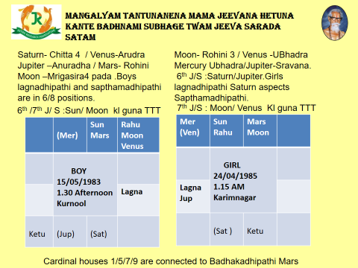

* Boy lagna is leo and Girl Lagna is Capricorn both are in 6/8 positions and lagnadhipathis are enemies (Sun and Saturn) 1/7 lords are enemies. Traditionally matched (acquire 25/36 points).
* Boy is Mrigasira 4 pada and girl is Rohini 3 pada (Sampaththara).
* Kamatrikona points acquired by boy are 25/100 and girl are 50/100.
* Gunas acquired by 7th lord in both the cases is **TTT which is not good.**
* **6th /7thJeeva and Sareera planets of the boy are Sun and Moon.**
* **7thJeeva and Sareera of the girl are Moon and Venus.**
* In both the cases badhakadhipathi is Mars
* BP Mars in boy is with lagnadhipathi Sun
* BP Mars in girl is aspected by Lagnadhipathi Saturn.
* 6thJeeva planet Sun of boy is in Vrishaba where the girl Moon is located and Moon happens to be the 7thJeeva planet of the girl.
* 6thSareera planet Moon of boy is with Venus and Venus happens to be the 7thSP ofthe girl in this way the JP /SP of the 6th of the Boy are connected to the 7th of the girl indicating marital discord.
* 7th lord Saturn in boy posited in the 3rd house aspects the 5th house Aspects Mercury and also the 12th house indicating the boy will go to court to file a legal case on his wife. The relationship ended up in a divorce.

DESPITE OF THE FACT THAT TRADITIONALLY MATCHED THEY GOT 25/36 POINTS BUT WHEN MATCHED IN MEENA 2 METHOD 1/5/7/9 LORDS WERE NOR COMFORTABLE AND THE j/s HAD 6/7 CONNECTIONS AND Kamatrikona points acquired were just average and the gunas acquired by the 7th lord in both the cases were TTT which is not good.

**EXAMPLE 2**

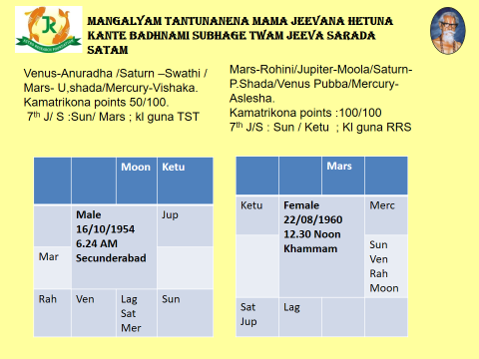

* Traditionally matched they got 7/36 which is very poor match.
* Man is Rohini4 and Female is makha 2.
* Male lagnadhipathi Venus aspects Girl Lagnadhipathi Mars.
* 1/7 lords Venus and Mars have mutual aspect.
* 5th lord Saturn in male happens to be in the star of Jupiter(Female 5th lord)
* 5th lord Jupiter of Female is with Saturn (5th lord of Male)
* 9th lord Mercury in male is in the star ofJupiter.
* 9th lord Moon in female is being aspected by Jupiter.
* Jeeva and Sareera planets of 5th house of Male are Rahu and Venus posited in Leo sign aspected by the Mars who is the 7th lord in male.
* Jeeva and Sareera of the 5th house of female are Ketu and Jupiter. Ketu and Jupiter aspect Venus who happens to be the Lagna lord of male.
* Jeeva and Sareera planets of male 7th house are Sun and Mars which are akin to the Jeeva and Sareera planets of female Sun and Ketu (kujavathketu).
* Kamatrikona points acquired by the male are 50/100 and the Female are 100/100.
* Gunas acquired by the 7th lord are TST in male while female 7th lord gunas are RRS.

With little adjustment and acclimatization the couple are leading a happy married life, under one roof. Despite of the fact traditionally matched 7/36 which was poor but the gunas acquired by the 7th lord were fairly good and the kamatrikona points acquired by the Female are 100/100 indicated that the female is adjusting nature to have a long sustained married life.

**References:**

1. **Practical stellar Astrology book by: Shri.Raghavacharygaru.**
2. **Jeeva&Sareera :Dr.N.V.R.A.Raja**
3. **Nakshatraprasna:Dr.N.V.R.A.Raja**
4. **Kalamsagunas:Dr.N.V.R.A.Raja**
5. **Class room notes dictated by Dr.N.V.R.A Raja sir.**
6. **NakshatraDigbala and Gunas : Dr.Satyasree Raja**
7. **Planets aspect and reflection by Dr.Hymavathi.**
8. **Nakshatrasiddhanta –Collection of pearls by Prof. NVRA .Raja Dr. Vijayalakshmi**
9. **You Tube talk by Prof. NVRA .Raja on marriage matching in July 2020.**

**ll Om Sri Sai Ram ll**

**ll Om Sri Gurubhyo Namaha ll**

**CHILD BIRTH - ASTROLOGICAL REASONS**

**BY LINKING KALAMSA & NAKSHATRA PRASNA**

* ***Dr. B. Hymavathi***

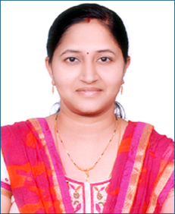

*Dr. Hymavathi Bhattar is a Nakshatra Sidhanta expert and also in Prasna Sastra. She is from eminent astrologer’s family. Her father late Sri. D. Gopala Krishna Sastry was also an eminent astrologer from A.P. She is a staunch devotee of Sri Satya Sai Baba and graduated from well disciplined Sri Satya Sai University, Anantapur.* *She did her Masters in Astrology from Osmania University and also from Yoga Samskrutam University. She has done research*

*work in “Reflection Theory” in astrology and awarded Ph.D. (Vedanga Jyothisha) from Yoga Samskrutam University, Florida, USA. Since 2015 onwards she is teaching Nakshatra Sidhantam at JKR Astro Research Foundation, Secunderabad. She is the recipient of many astrology titles and currently she is a research supervisor guiding many students in Vedic and Nakshatra Sidhanta.*

Birth of the child brings about immense joy to the married couple. As soon as a child enters into the life of a couple, their whole life is dedicated in nurturing that 'bundle of joy'. They take immense joy in watching their 'little flower' blossom every day. Child Astrology is an aspect of astrology that makes childbirth prediction and is highly beneficial to the couple.

**CHILD BIRTH**

**HOUSES:** 5th house, 2nd house and 11 houses have to be analyzed for the child birth.

* 5th House is the primary bhava for children.
* 2nd House is Family.
* 11th House is the fulfillment of Desires, Labha or Gains. This is also 5th house (Putra Sthana) to the 7th house of Spouse.

5th House is also the labha sthana for the 7th House.

**JUPITER** is the natural significator of Child Birth.

**SIGNS:** In the Zodiac, out of 12 signs some are fertile and fruitful signs and some are not barren.

FERTILE SIGNS:All watery signs are fertile signs. They are Cancer, Scorpio and Pisces. Out of all watery signs Cancer is the most fruitful sign. Because Moon is the lord of this house and Jupiter gets exalted in this house.

BARREN SIGNS**:** Aries, Gemini, Leo, Virgo are Barren signs. Fiery signs (except Jupiter sign) Aries, Leo and Mercury signs (Gemini and Virgo) are considered as Barren signs.

SEMI FERTILE SIGNS: Taurus, Libra, Capricorn

SEMI BARREN SIGN: Aquarius

**FERTILE PLANETS & BARREN PLANETS**

* Fertile Planets : Jupiter, Venus, Sun, Moon and Rahu
* Barren Planets : Mars, Saturn, Ketu
* Mercury sometimes acts as a fertile planet and sometimes as Barren planet.

One should not misunderstand that Barren planets do not bless the native with child birth. Any planet if it is well placed in the horoscope and has benefic connections signifying the event strongly malefic or benefic confers child birth to the native.

**12 BHAVAS – CHILD BIRTH**

Let us look at all the 12 bhavas with reference to Child Birth.

* 2,5,11 Houses – Houses of Child Birth
* 9th House – Supports the houses of Child Birth, facilitator
* 1,4,10 Houses – Negates the event (Vyaya Bhavas (12th) of 2,5,11 houses).
* 6,8,12 Houses – Complications/miscarriages/abortions
* 3,7 Houses – Neutral

**PROMISE OF THE CHILD BIRTH**

* When 5th house or Jupiter is strongly connected to 2nd house, 5th house and 11th houses and favourably posited, have benefic planets connections then child birth is promised in the horoscope.

**DELAY IN THE CHILD BIRTH**

* When 5th house or Jupiter is connected to Maraka and Badhaka sthanas or their lords, then delay in the child birth is expected.
* When 5th house or Jupiter is connected to Barren/ Separative Planets like Sun, Mars, Saturn, Rahu and Ketu child birth is delayed.

**DENIAL OF THE CHILD BIRTH**

* When 5th house or Jupiter is strongly connected to 1,4,10 houses (negating bhavas of child birth) + Barren Planets + Barren signs – then child birth is denied.

**DASA-BHUKTHI-ANTARA**

When Dasa / Bhukthi / Antara signifies

* + 2,5,9,11 houses/Jupiter (for both male and female) – child birth is denoted
  + 6,8 or 8,12 houses + Mars/Ketu - Surgery
  + 6,8,12 houses – complications/difficulties during Pregnancy period
  + 6,8,12 houses + Rahu/Ketu/Saturn – promotes miscarriages/abortions
  + 1,4,10 houses – denial of the event

Dasa lord should at least be neutral (without denying the event). But Bhukthi lord should indicate the event very strongly.

**TRANSIT**

Even though the event is promised in the birth chart and suitable DBA is running to the native, the event will not happen without favourable transit. DBA lords should favourably transit and also 5th house connected planets.

Here is a very simple and easy method to identify timing of child birth.

* **1 – Self;**
* **5 – Children;**
* **9 – Father**

They all belong to the same lineage and these houses are interlinked with each other.

**Jupiter** is the natural significator of child birth. So, when Transit Jupiter is connected to 1-5-9 houses child birth is indicated.

**EXAMPLE HOROSCOPE**

Let us analyse this chart by linking Kalamsa Theory and Nakshatra Prasna propounded by Poojya Guruji Sri. N.V.Raghavachary, Meena2 and further developed by Guruji Dr.N.V.R.A.Raja, Meena2Jr.

**FEMALE: DOB-20.11.1960, 09.18 AM, Guntur**

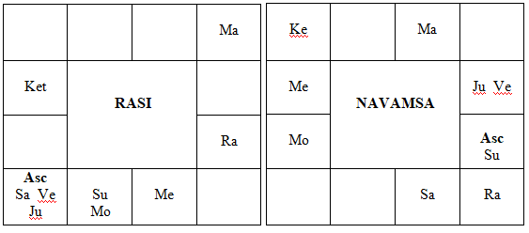

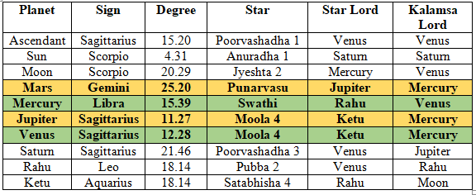

The native was married on 18.03.1976 (Ket-Rah-Jup). But after 6yrs of her marriage she begot the child on 22.08.1982 in Venus-Venus-Saturn.

**ANALYSIS**

Let us analyse child birth factors in the horoscope.

Native’s Lagna is Sagittarius. Child birth is seen from 5,2,11 houses and Karaka planet Jupiter.

1. 5th lord Mars is posited in the 7th house in the star of Karaka planet Jupiter and it is aspected by 2nd lord Saturn, 11th lord Venus and Jupiter, Karaka Planet.
2. Both 5th house and 5th lord are aspected by Jupiter.
3. All the associated planets to the 5th lord Mars are significators of child birth.
4. Here, bhavadhipathi 5th lord in the star of karaka planet and aspected by Karaka planet from a good house.
5. Star lord and Karaka planet Jupiter is in its own house and also having digbala is powerful and conjoined with 2nd and 11th lords Saturn and Venus. Saturn and Venus also have Nakshatra Digbala.
6. Being shadow planet, Ketu- star lord of Jupiter gives the results of its sign lord Saturn which in turn conjoined with Jupiter in Jupiter’s house.

**Let us look at the Kalamsa lord of 5th lord Mars and Jupiter**

1. 5th lord Mars is in the Kalamsa of Mercury which is posited in the 11th house of gains or desire fulfillment house.
2. Karaka Planet Jupiter is in the star of Ketu but it is also in the Kalamsa of Mercury which is placed in the labha sthana.

Hence child birth is promised in the chart.

**But there will be delay in the event due to following reasons**

1. 5th lord Mars is in Gemini which is a Maraka and Badhaka house.
2. 5th lord Mars is aspected by Saturn. Even though Saturn is the lord of 2nd house, it is also a Separative planet and Marakadhipathi for Sagittarius Lagna.
3. Jupiter Karaka Planet is in the star of Ketu which is a Separative planet and conjoined with delay planet and Marakadhipathi and also Separative planet Saturn.
4. Mercury, Kalamsa lord of 5th lord Mars and Karaka Planet Jupiter is in the star of Rahu which is a Separative planet.

There was only a delay and not denial.

**The lady delivered her 1st child on 22.08.1982 in Venus Dasa – Venus Bhukti and Saturn Anthara.**

**We will look at the reasons why Venus Dasa conferred child birth to the native.**

VENUS

Venus is the 11th lord of labha conjoined with Karaka planet Jupiter and 2nd lord Saturn of family. It is also aspected by 5th lord Mars. Venus also gained Nakshatra Digbala with the association of 4th lord Jupiter.

KALAMSA LORD OF VENUS

Mercury is the Kalamsa lord of Venus. 11th lord Venus is in the Kalamsa of 11th house occupant Mercury and both has to give labha or gains to the native. Rahu Star lord of Kalamsa lord Mercury is in the yogakaraka house and it is aspected by Putra Karaka Jupiter. **Further, Venus is in the Kalamsa of Mercury. Mercury is the significator of child birth in this chart. Because Mercury is also Kalamsa lord for 5th lord Mars and Karaka Planet Jupiter who are significators of child birth.**

One more interesting point is that Venus is in the Kalamsa of Mercury and Mercury is in the Kalamsa of Venus. There is exchange in Kalamsas. Hence Venus results will be given by Mercury and Mercury results will be given by Venus.

Therefore Mercury which is the Kalamsa lord of 5th lord Mars and Karaka planet Jupiter is also Kalamsa lord of Venus and so gave its results through Venus.

Labhadhipathi Venus which gained the association of 2nd, 5th and Karaka planet Jupiter is also in the Kalamsa of 11th house occupant Mercury which is already a significator of child birth. Further it is supported by exchange of Kalamsas.

Antara lord Saturn is in the Kalamsa of Karaka Planet Jupiter.

**Hence the event happened in Venus Dasa - Venus Bhukthi – Saturn Antara.**

**TRANSIT CHART ON 22.08.1982**

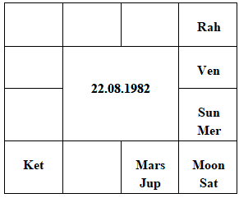

Jupiter is transiting on natal chart Mercury (Kalamsa lord of 11th lord and Dasa lord Venus, 5th lord Mars and Jupiter). Jupiter joined 5th lord Mars in the 11th house and aspecting natal chart 5th house and also 5th lord Mars. Kalamsa lord Mercury is aspected by natal chart Jupiter. Rahu star lord of Kalamsa lord Mercury is transiting on natal chart Mars (5th lord) and aspected by both natal and transit Jupiter.

This chart was discussed on 22.01.2021 in the Nakshatra Prasna quiz group at 10.44PM.

Here is the Nakshatra Prasna Chart @ 10.44PM, 22.01.2021, Hyd.

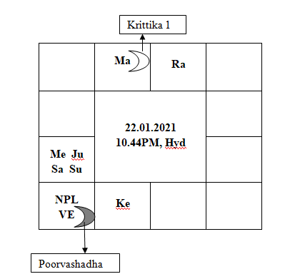

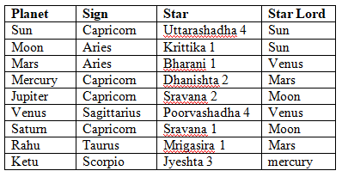

DRM – Krittika 1

HRM – Poorvashadha

NPL – Sagittarius

JEEVA – Venus

SAREERA – Saturn

**BRIEF NAKSHATRA PRASNA ANALYSIS**

1. HRM is in the star of Venus and so Venus posited house Sagittarius becomes the Nakshatra Prasna Lagna. Native’s Birth Chart Lagna and NPL Lagna are both same Sagittarius.
2. DRM is placed in the 5th house conjoined with its house lord Mars and the event happened is child birth.
3. DRM star lord Sun is 9th lord, Yogakaraka which is sitting in the 2nd house along with its lord Saturn, Mercury and Jupiter. All are significators of child birth in the Birth Chart and also in Nakshatra Prasna Chart.
4. HRM is in Venus star and 11th lord Venus is placed in the Lagna both in NP Chart and Birth Chart.
5. JEEVA planet is Venus and SAREERA planet is Saturn and the event happened in Venus Dasa-Venus Bhukthi-Saturn Antara.

Nakshatra Prasna is the crown of Prasna Sastras and thanks to my Guru Dr.N.V.R.A.Raja garu for giving this great subject to all of us and blessed to learn this sastra directly from him.

May the almighty shower his choicest blessings on each and every one!!

Om

Jai Meena 2

**AN ASTROLOGICAL ANALYSIS BASED ON MEENA 2 PRINCIPLES**

* ***Dr. Hemalatha A. Krishnan***

*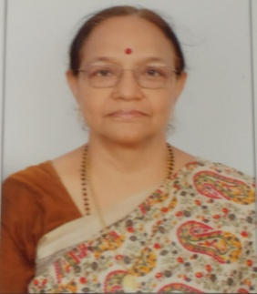Dr. Hemalatha A Krishnan is a faculty, teaching Meena 2 Nakshatra Siddhantam at the JKR Astro Research Foundation, Secunderabad since its inception in 2011.  A Retired Banker, she has done research on Uttama drekkana, one of the pillars of the Meena 2 System and was awarded Doctorate by the Yogasamskrutham University, USA in the year 2018.  She is a recipient of many Titles for her contribution to the cause and spread of the Divine subject of Astrology.  She has a passion for teaching with a lot of commitment.*

The Meena 2 Nakshatra Siddhantam is a fine-tuned system of predictive astrology where the star lords of the planets posited in a bhava, play a greater role in delivering the results of the bhava, according to their ownership and placements.

Let us analyse a horoscope with this principle.

KAMALA HARRIS is an American politician, member of the Democratic party, a lawyer and an author. She is the United States’ first ever Vice President, the highest ranking female elected official in the US history and the First Indian origin, African American Vice President. She is one of the 100 most influential people in the world and one of the 20 of America’s most powerful women.

She became known for championing causes dear to her heart such as defense of molested people, the better control of fire-arms, the dialogue with immigrants, public safety, reforms efforts like death penalty, consumer protection against fraud, waste and abuse, privacy rights, environmental protection, truancy initiative and campaign for awareness of drugs. She has authored non - fiction and children’s books. Above all, she is a powerful symbol of all that women across the globe aspire to be.

She has created History beating Sexism and Racism. With her call for Unity, she assumes office amidst historic challenges such as pandemic, a divided country and economic challenges.

**KAMALA HARRIS:** DOB: 20/10/1964, TOB:21.28 HRS, POB: OAKLAND, CALIFORNIA

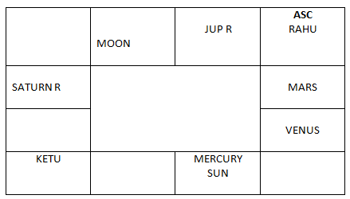

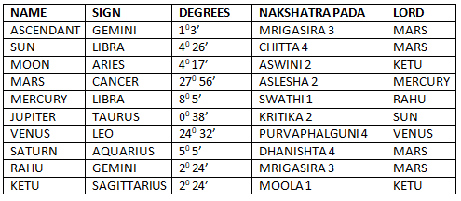

**ANALYSIS**

The Lagna pada is Mrigasira 3. Mars, the lord of 4 and 11 is posited in the 2 house.

The Lagna is Gemini, the natural 3rd sign, an airy sign with its lord as Mercury. The native is an intellectual, brilliant, imaginative, and versatile and has a refined temperament and wisdom. She is quick and alert, creative, has powers of expression, is an eloquent speaker and a diplomat true to a mercurian. She is a friendly, pleasant and jovial personality, emotionally sensitive and compassionate. She is also curious, quick witted, enterprising, ambitious, lively, clever and flexible.

The Lagna lord Mercury is posited in the 5th house, Libra in the star of Swathi 1, Uttamadrekkana. When the Lagna lord is situated in Uttama drekkana, the natives are likely to be eminent, influential, famous, powerful, educated, wealthy commanding respect. They have name and fame apart from high status in society and lead a comfortable life.-----Guruji Sri N.V.Raghavachary.

Mercury gets nakshatra Digbala as its star lord Rahu is posited in the Lagna. The lagna gets fortified as the Lagna lord is placed in the house of Yogakaraka, the Venus along with the Sun, the karaka for name, fame and status. Mercury is also the 4th lord. Her mother has been an inspiration for her, encouraged her to be socially active and led her to believe that the world is a place for peace, justice and equality.

The occupant of the lagna is the Rahu in the star of Mrigasira 3, the lord is the fiery Mars. Rahu in lagna gives the drive to achieve big things. The native tries to prove herself in a public platform, is conscious of her image and aware of what is going around he. Rahu gives the results of its sign lord Mercury (Lagna lord and 4th lord) and its star lord Mars (lord of 6th and 11th). Rahu in the house of Mercury bestows a great analytical ability to the native, to think, strategies and then execute waiting for the right opportunity to strike. She is a shining example of “The iron fist in the velvet glove” as she is known to convey rather heavy things to people in a soft voice.

The 2nd lord Moon is posited in Aries in Aswini 2 in Uttama drekkana. Moon gets Nakshatra digbala being aspected by the 4th lord Mercury. This is a full moon and such a disposition, where the luminaries, the Sun and the Moon get strength, is a boon for the native, giving an inherent strength to ward off other negative positions to some extent. The strong Moon in a fiery sign has made the native impulsive, ambitious, and extremely competitive. She isn’t afraid to step into the ring and fight against all odds. Such a Moon, karaka for mind, gives an ability to reach the scene of emergency rescuing people and counseling them. The 11th house is the house of relationship to the society at large and a strong Moon in the 11th has been of great help. The Moon is aspected by the Lagna lord, Mercury and the Sun from the 5th house and Saturn from the 9th house. The Venus aspects the Saturn in the 9th house and Saturn in turn aspects the Moon. So, the Moon also aspected by the Yogakaraka Venus as per the Reflection Theory propounded by DR.N.V.R.A.RAJA.

The 2nd lord Moon is in the star of Ketu and Ketu gives the result of Jupiter. This dhanakaraka Jupiter posited in the 12th house shows the charitable disposition of the native. The occupant of the 2nd house is Mars. Mars is debilitated but there is sthoola parivartana between the Moon and the Mars, so they give the results as though they are in their own houses.

The 3rd lord the Sun is placed in Libra. Sun is in the 5th house and gets connected to the 4th house being in the Bhinnapada nakshatra of chitta, Mars.

When the constellation in which a planet is posited spreads in 2 houses, one can expect the results of both the houses to be given-------------------PSA RULE by Guruji Sri N.V. Raghavachary.

Though the Sun is in debilitation, there is sthoola parivartana between the Sun and the Venus, so they give results as though they are in their own houses. Sun the karaka for name, fame, status, honors is in chitta 4, Uttama drekkana, strong in the house of Yogakaraka Venus along with the strong Lagna lord Mercury. Hence the Sun has blessed the native with all aspects of 3rd house, courage stamina, vitality, communication, friendship and transformation. This combination of Mercury and the Sun is aspected by a strong Moon and the fiery Mars. The occupant of the 3rd house is the Yogakaraka Venus in its own star aspecting the bhagyasthana, the 9th house, one of the great trines.

The Venus the lord of the 5th and 12th houses is posited in the 3rd house in its own star. Venus is the Yogakaraka for the native.5th houses is the seat of throne and power. The 12th house shows charity, social services, donations generosity and contributions to society. The occupants of the 5th house are the Sun and the Lagna lord Mercury. As mentioned earlier the Sun gets connected to the 4th house and Mercury is the 4th lord. This connection of the 4th and the 5th houses, a kendra and a kona is a Rajayoga.

The lagna lord Mercury is posited in the 5th house and its star lord Rahu is in the Lagna.

For the native to enjoy the fruits of a house, the Lagnathipathi or the Lagna should be connected or associated with the respective houses-----------------PSA RULE by Guruji Sri N.V. Raghavachary.

The Mars, the lord of the 6th and the 11th houses is in the 2nd house even though Mars is apparently in debilitation, it is in Aslesha, the star of Mercury who is the lord of the lagna and the 4th house posited in the 5th house.

When planets are well placed in the constellations with strength, good results ensue even though they are Neecha in the Rasis ----------------------PSA RULE by Guruji Sri N.V Raghavachary.

The malefic Mars in the 2nd, kutumbasthana aspecting the 4th lord Mercury and the 9th lord Saturn shows the trauma the native had in her family on account of separation of her parents and thereafter. However, the dispositor of Mars, the Moon is very well placed, strong in the 11th.

The 7th house indicates public support. Rahu aspects the 7th house from Lagna. Rahu is a political planet as only Rahu can capture the public minds. The occupant of the 7th house, the Ketu gives the result of its sign lord the Jupiter, the lord of the 7th and the 10th houses. Ketu helped the native to penetrate to the roots of the system for survey and explains the multidimensional view of her working for the cause of the society. She formed string groups around her to climb the ladder to reach the present position. Her career in politics is a success journey.

The 9th lord Saturn is posited in Aquarius in its own house in an airy sign in Dhanishta, the star of Mars, the lord of the 6th and the 11th house, clearly showing that her house of fortune is directly linked to the houses of winning over her opponents in competition. The Saturn aspects the Moon in the 11th, the Venus in the 3rd and the 6th house of service and competition. Saturn, the karaka for profession is a task master and gives the native a taste for hard work, dedication, commitment, straightforwardness, honesty and reliability. This also deceits the slow, wise and deep mental process to succeed over enemies and litigations. The 9th house of fortune and justice is being aspected by the Yogakaraka, Venus giving the wealth of character, forbearance and steady wisdom. Kamala Harris stands tall on her feet firm on her convictions.

The Lagna with Rahu, Sun and Mercury and Saturn all occupy the great trines, 1,5,9 in airy signs promoting new ideas, mind speculations, giving flexibility and adaptability to her. Rahu, Sun and Saturn are in the star of fiery Mars where she is forever facing a stiff competition and succeeding.

The 10th lord Jupiter is posited in Taurus, an earthy and materialistic sign in the house of Yogakaraka Venus, in Kritika, the bhinnapada star of Sun, thereby getting connection to the 11th house of gains, success and fulfillment of desires. The 10th house indicates profession, with Jupiter as the planet for law and justice, she began her career as a lawyer and gained a good reputation as progressive prosecutor. the star lord of the 10th lord Jupiter, the Sun is posited well posited in Libra, the courtroom and place of justice along with the lagna lord Mercury, giving decision making ability to bring about change, fairness, justice and equality. The Jupiter gets Nakshatra digbala as its star lord Sun is with the lagna lord. The Jupiter in the 12th house aspecting the 6th house of service, addresses the greater goals of international fame, deriving much pleasure fighting for the right cause and law enforcement

Madam Kamala Harris took oath as the 49th VICE PRESIDENT of THE USA, on the 20th January 2021 at 11.41 a.m. She wore the color purple which is traditionally seen in the US as a symbol of bipartisanship. It is also the color of women’s suffrage. She was seen donning pearls, a symbol of Kamala’s sorority and the black sisterhood that has supported and sustained her. She was going through Rahu Mahadasa, Mercury Bhukti and Venus Antara.

Dasa lord Rahu, posited in Lagna, is transiting over the 10th lord Jupiter in Taurus, being aspected by the 10th lord Jupiter in Capricorn, which is the 10th house from the Moon. Rahu is transiting in the star of Mars, the lord of the 6th and the 11th houses, showing win and success over competitors.

Bhukti lord Mercury happens to be the strong Lagna lord, transiting in the 10th house of profession and status along with the 10th lord Jupiter, Saturn, karaka for profession and Sun the karaka for name, fame, royal honors and Government service. Mercury is also transiting in the star of Mars and gets connected to the 11th house of gains and fulfillment of desires through Bhinnapada.

Antara lord Venus, the 5th lord is the Yogakaraka transiting in its own star in the 9th house from Moon aspecting the Gemini Lagna.

The Lagna is Aries, the fiery 11th house of the native. The Moon is transiting over the natal Moon in the 11th house of success in the star of Aswini, the Ketu who represents the 10th lord, Jupiter. The Native is blessed to be a powerful woman with strong attributes and a ‘never give up’ attitude. Her life’s mission seems to be to create unity by any means necessary. She has proved that anything and everything is possible. The ensuing period of Rahu Mahadasa and Venus Bhukti may see her fight the Presidential election. She said in her oath “so help me God”.

References:

1. Practical Stellar Astrology by Sri N.V.RAGHAVACHARY

2. Lectures by Dr.N.V.R.A.RAJA

3. Kamala Harris-Wikipedia and analysis

**PREDICTIONS BASED ON TARABALAM**

* ***DR. P.Siva Sarma***

*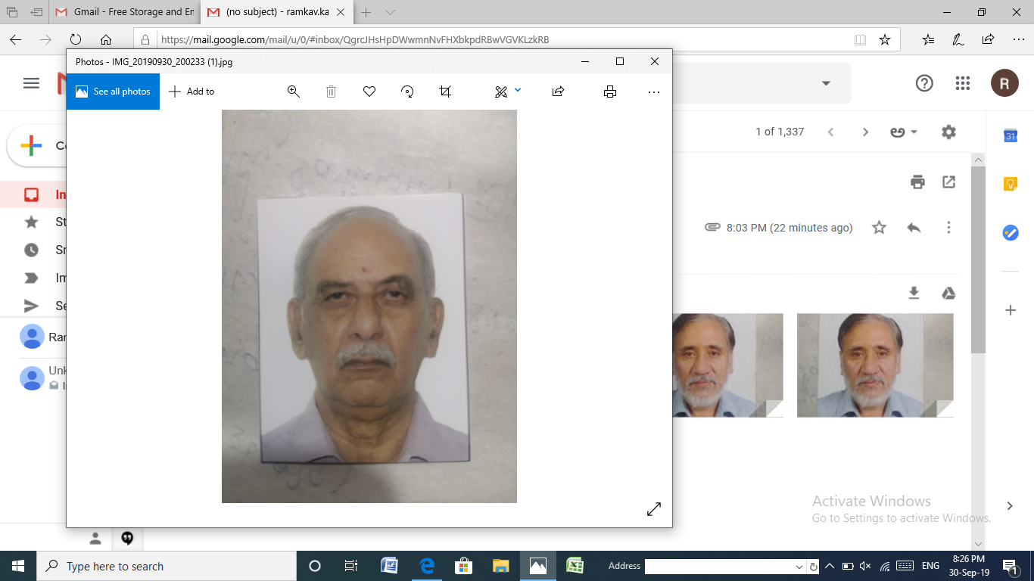Dr. P.Siva Sarma,*

*M.Sc., Ph.D., M.A (Vedanga Jyothisha-Y S University-Florida, U S A) Associate Professor in Botany (Retd). Presently He is a Senior Faculty Member at JKR Astro Research Foundation'*

*Prof. Sarma is an author of many scientific research articles and books; He is recipient of AP Govt's Best Teacher award & DG NCC's National award and many others. He is a recipient of many Astrology titles.*

The earth on which the entire living world, including the human beings lives is greatly influenced by the energies and forces of celestial bodies. These celestial bodies are the static star constellations, signs, and ever moving bodies called planets. The constellations pass on the celestial energies to the continuously revolving planets of the universe. These energies and forces are further transferred through rasis. These energies/ forces cause the events and also control the events that happen during the life cycle of a native. This is the important role played by constellations, which forms the basis of Stellar Astrology.

In the universe although there exists a large number of constellations, we are aware of only twenty seven constellations, which have a profound impact and influence on the life and living activities of human beings living on the earth. These stars are named as Ashwini, Bharani……. etc.,

Moon, the fastest moving planet, during the course of its rotation round the earth, will be positioned, for a day, in one these constellations.

The star in which the moon is posited is called “Janma Tara” for the native born on that particular day. The next day Moon moves into another star, which becomes the second star and is called the “Sampath tara”, for the Janma tara mentioned earlier.

Our Astro scientists - Rushi’s have prepared table called “TARABALAM” based on the interrelationships between all these twenty seven stars, indicating the influence of each one on the other star. In this table all the 27 stars are grouped into

1. Janmatara
2. Sampath tara
3. Vipath tara
4. Kshema tara
5. Pratyuk tara
6. Sadhana tara
7. Naidhana tara
8. Mitra tara
9. Parama mitra tara. (Table)

The stars which are designated as 3.Vipath Tara 5. Pratyuk tara 7. Naidhana tara

are considered as not so favourable ones for the specified Janma tara (Table )



DASA SYSTEM: As students of astrology we all know that a native is born in this world to experience or go through the ‘Prarabdha Karma’ of the past life, and present Sanchitha karma. These Karma phalas will be experienced by the native at an appropriate time, called “Dasa period”.

The dasa period is calculated following the popular “VIMSHOTHARI System, taking Moon posited ‘Janma tara and the planet which is it’s Star Lord. The different dasa periods are drawn for native in a sequential order, starting from the Janma tara and it’s starlord.

It is now clear that a native’s Janama tara is the basis for calculating “Dasa

Periods” and also “Tara balam”. A meaning full blending of the Tara balam and Dasa concepts can be made use in predicting the timing of events.

It can be said that during the particular Dasa, Bhukthi, Anthara periods of those planets which are associated with corresponding Tarabalam, the events will happen.

This concept will give a new direction and approach, support and supplement to traditional analysis of prediction. Lets analyze the below chart to understand this concept.

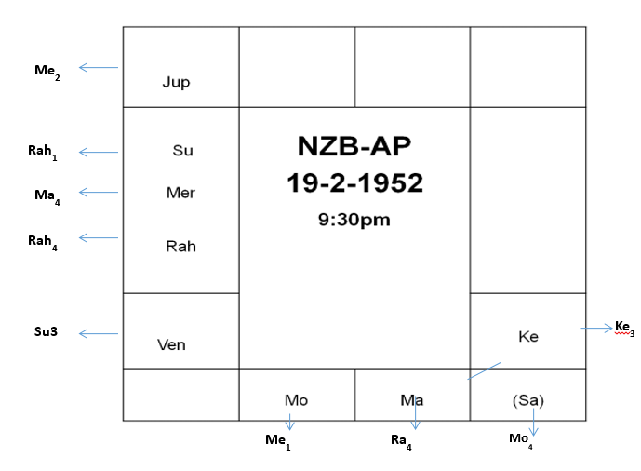

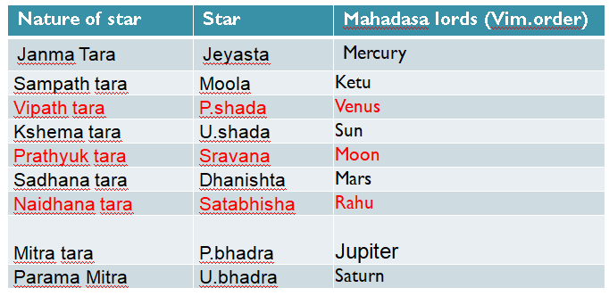

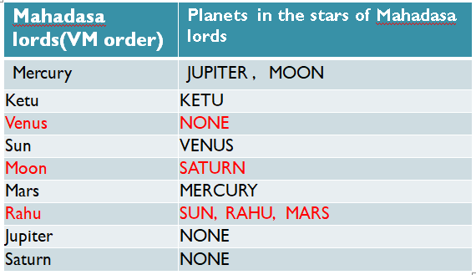

So thus it can be said that during the dasa, bhukthi and anthra periods of the planets associated with

* Naidhana tara-- SUN,MARS,RAHU
* Prathyuk tara -- MOON & SATURN
* Vipath tara -- VENUS

Unfavorable sorrowful events like loss, anxiety, death can be predicted.

Confirming the same on 25 th December 2000, when the native was running Moon (Dasa); Mars (Bhukthi); Sun (Anthara) he died and left for heavenly abode.

If there is association or aspect of benefic planets such unfavourable events ward off.

However more, in depth research is needed to uphold this concept.

!! Om Sree Gurubhyo Namaha !!

**Vimshottari Dasa System – Moon’s Decisive Role**

* ***J. Somanath Sastry***

*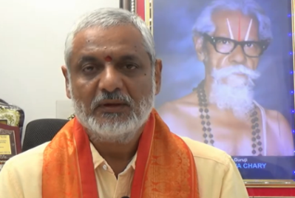After retiring from a Public Sector Bank from its executive cadre, Sri Sastry completed M. A. (Vedic Astrology) in 2014 while learning Meena2 Naadi System in Makha batch. For his flair for teaching with clarity on the basics, Sri Sastry is made faculty member since 2014. He collects and shares a wealth of*

*information on astrology at every stage of learning to the students. He has strong commitment for imparting astrology*

*with a modern and logical approach. He received M.A. in Vedanga Jyotisha degree of Yoga-Samskrutham University in 2017.*

|  |
| --- |
| **Author’s Note:**  **The unexplored logic and reasoning behind many astrology basic concepts have been my area of interest ever since I am exposed to this domain of ancient knowledge. In every astrology class, I learn new dimension to the origins of the concepts. I am presenting the outcome of such thought process in this article and the title of this article gives idea about it.** |

The very purpose of Astrology is to indicate and give guidance on native’s destiny of current birth with Karma Siddhanta as its base. There is no way to draw the natal chart of next birth of any native.

Interestingly, Astrology is thought of and developed by our great Rishis for human beings only, even though they realized that the “causing factors” for “whatever is happening on earth” is 3 celestial objects only (Nakshatras, Rasis and Planets through their energy rays reaching the earth).

In the process of studying Astrology with a scientific perspective, one understands that the entire universe consists various forms of energy and all living beings on earth are different ‘formats’ of energy only in this universe. Then, why Karma Siddhanta is not applicable to all the other living beings on earth is a pertinent question. To get the answer to this, one needs to know the difference between human beings on one hand and all the other living beings on the other hand - on earth.

1. All other living beings on earth live ‘abiding by’ the nature’s laws ‘religiously’ and do not have the concept of TIME as human’s have (Past, Present and Future).
2. None of the living beings on earth (other than human beings) have a ‘thought’ on ‘producing’ food from nature for future use by tampering with the nature if required (e.g. construction of heavy projects)
3. None of the non-human living beings have “*Karmadhikara*” (discretion to the deeds they perform) while human beings have it.
4. The *Karma phala*“gets accumulated”during living of all the 84 lakh formats of living beings (including human format) while the “discharge” of Karma Phala is possible only in human format because this format only has *Karmadhikara*.
5. Any soul must be born, one day or the other, in human format by default to get the accumulated karma phala (*sanchita karma phala*) discharged in many installments, that is, in many births. Each installment is known as *prarabdha karma phala* for that birth.
6. The soul (consciousness) is in cosmic journey of “from purity to purity” taking the support of ‘body’ (energy).Its schedule of journey is ‘automatic’, not controllable by GOD also (Strangely, GOD concept is not there in Astrology) but depending on the Karma phala balance.

Therefore, Astrology is relevant and concerned with life of human beings only and happening of events (i.e. life) are indicated by the 3 celestial objects only through the natal chart. Thus, the Natal Chart is considered as SOURCE OF EVENTS of the Native’s life (period covered is from birth to death).

If the natal chart is‘source’ of events (life), the other tool developed by Rishis to find out when the event can be materialized, is the second important Astrology Tool gifted by them, known as Dasa System.

In using the knowledge of Astrology (to get indication of prarabdha karma phala discharge plan), the following steps are involved.

1. Drafting of positions of celestial objects at the time of birth in the form of a Chart (*Kundali*) – Natal Chart.

2. Knowing of *karakatvas* (Significations) of *Rasi* (Zodiac Signs), *Bhava* (Houses) and *Graha* (Planets) to understand the Native’s Prarabdha Karma Phala Discharge Plan.

3. Analysing the Natal Chart or blending of karakatvas – that is, applying the knowledge of Karakatvas to the position of celestial objects in a Chart.

4. Understanding the positions of Static (Nakshatras & Rasis) and Dynamic (Planets) celestial objects in the Chart to get indications about Events that may happen based on their positions and karakatvas.

5. Find out when the indicated events will happen in the life time of the Native.

6. Estimate when the possible happening of events can be fructified.

This is all to make the life comfortable and have minimum inconvenience in discharging the Prarabdha karma phala during the life time of native.

The crux of application of astrology knowledge is to correlate the fixed position of celestial objects in the natal chart with the expected time of happening of indicated events in the natal chart – based on movements of ever moving, dynamic celestial objects, i.e. Planets.

The Planets move on, after the moment of the birth, and their position at the time of birth becomes only a record of **Source of events** in the life of the Native. Therefore, the Astrologer needed to have some more tools to go along with Planets in their journey to know or understand the **timing of events** due to celestial influence on life after the birth.

**It is found by Rishis after an extensive research that, a native’s life events will happen with the influence of Nakshatras positioned in the TRINE of the Natal Chart starting from the time of birth.**

The nakshatra which starts influencing of happening of events needs to be identified first to draw the possible timings of events to happen. Once the nakshatra is identified, its Lord can be taken as base for knowing further schedule.

It is already established that set of three nakshatras are fixed in the Zodiac which have 120 degree angular relation. The list of those nakshatras is given below.

Set of three nakshatras having 120 degree angular connection (Trine) in the Zodiac

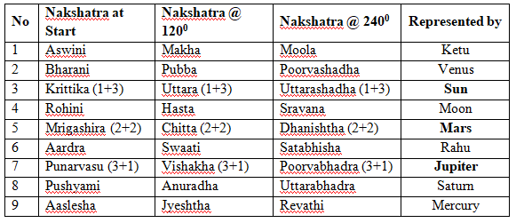

**To identify the nakshatra which can START influencing the native for timing of happening of events,** it could be taken as the nakshatra which is at Eastern Horizon at the time of birth. But that is representing Native itself. Therefore, another nakshatra has to be found. For this, Rishis checked the speed of each nakshatra in influencing the native through the **speed of its occupant** planet **at the time of birth**. The normal speed of planets while transiting a nakshatra is as under.

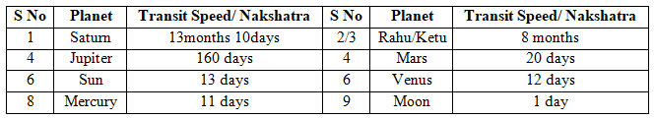

**It is obvious from the above that the nakshatra which has fast motion (identified through the motion of its occupant) will be the nakshatra in which Moon is posited, always.**

They concluded that Moon posited Nakshatra along with its other two companions will cause timing of happening of events to the native first. The Lord of that Nakshatra can therefore be taken as the **‘Starter’** to cause timing of happening of events to the Native. After that, the other nakshatras of the set will as per the sequence will cause timing of happening of events.

Under the Vimsottari Dasa System, since Native’s life is considered to be 120 years (corresponding to 120 degrees of a Trine) the sequence of Nakshatras (represented by its Lord) that will be ruling the life of Native can be found starting from the Star Lord in whose nakshatra, the Moon is posited at the time of birth. **Thus, Moon has become decisive planet to decide starting Dasa Lord.**

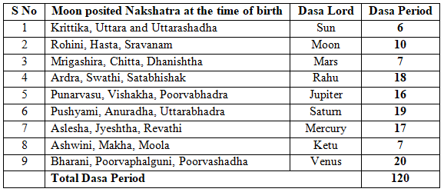

Thus, if Moon is posited in Krittika or Uttara or Uttarashadha at the time of birth, the Dasa period of those nakshatras wil be the First Dasa represented by their Lord, i.e. Sun for 6 years.

Therefore, the Star or Nakshatra in which Moon (also the nearest planet to the Earth) was transiting at the time of birth, also called janma nakshatra (birth star) is the key in this system.

**Moon’s longitude to decide lapsed and remaining First Dasa period:**

Length of First Dasa Period is also decided based on **Moon’s Longitude at the time of birth** in the concerned Nakshatra. That means, First Dasa period (equal to allotted number of years to the concerned Star Lord) will start when Moon enters the Nakshatra and ends when Moon moves into next Nakshatra.

If a native is born when Moon is in half way in a Nakshatra, the **First Dasa period for the native will be proportional** and therefore it will be half only of the Total Dasa period to that native.

The starting dasa period is co-terminus with exit of Moon from the Star. Further Dasas will be for full period.

Moon has fastest motion moving through one nakshatra a day and thus became the Decisive celestial object in the Dasa System. The star in which Moon is posited at the birth time is, therefore, very important for entire life of the native on par with the Ascendant Sign. That is the reason why in many calculations, the Moon Sign (Janma Rasi) is treated equal to Ascendant Sign in reading the horoscope.

In Gochara, Moon Sign only is considered to know the benefic or malefic influence of planets on the native.

**/// Swasthi ///**

SRI GURUBHYONAMAHA

SRIRAGHAVACHARYAM

**THE ROLE OF VENUS IN BIRTH CHART AND**

**ESPECIALLY IN THE PRESENT SCENERIO**

***- Prof. Muralidhar Patnaik K.V.***

*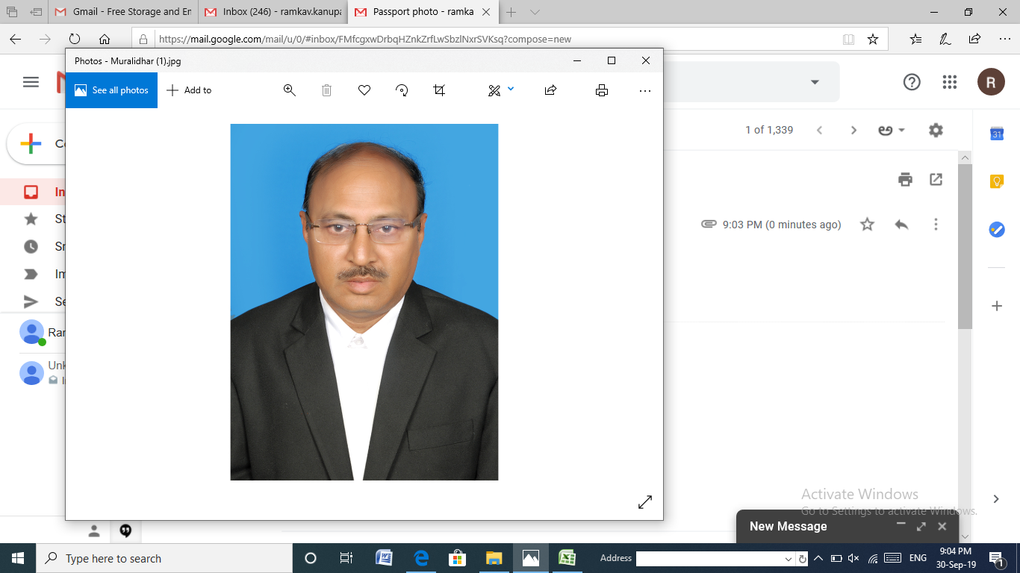MURALIDHAR PATNAIK K.V.*

*M.A.(Astrology), LL.B., M.A.(Psychology & Philosophy), Ph.D. Advocate in High Court of Telangana and A.P. & Panel Advocate to AP Grameena Vikas Bank, H.O., Ranga Reddy, Sangareddy Regions. He Completed his M.A. in Astrology from PS Telugu University during 2007-2009 and P.G.Diploma in Jyothirvaidyam in 2010. Joined in JKR Astro Research Foundation on 11-09-2011*

*and completed Jyothisha Siromani Course. Took Ph.D. in 2016 in Medical Astrology from YSAM University, Florida under the guidance of my mentor Prof.N.V.R.A,RAJA Sir. He joined as a Faculty in 2017 and YSAM University rewarded with Faculty & Professorship.*

Pranams to Pujya Guruji Sri N.V.Raghavacharygaru,

Pranams to my Guruji and mentor Prof.N.V.R.A. Raja garu.

Today entire world is frightened by Carona Virus which has affected the comfort levels of people, their regular habits, their daily enjoyment so on and so forth. People's wisdom and intelligence is in blank state without knowing how to counter the present situation. I want to relate this aspect from astrological point of view and the planet which we should discuss at this point is Venus, the planet which gives comforts. We should also correlate Mercury, the planet which drives our intelligence to resist the situation and Moon which rules the Mind.

Venus is a brilliant planet and it appears in the sky as evening star in some months and as morning star in some months. Venus is the brightest planet. Venus is much closer to Sun than the Earth. Venus will be in between Sun and Earth in some occasions and in other occasions Sun will be between Venus and Earth. The size of Venus is similar to Earth. Venus can never be more than 48 degrees from the Sun. That is why Venus and Sun transit in same sign or in neighboring signs in the zodiac.

Venus is a pleasant partner, Rajasic in nature, belongs to priestly class. Venus is chief governor for **marriage, Kalathra Karaka**. It shows whether one will lead happy married life or experience hell with life partner. Venus is a feminine planet. Being feminine, it governs the gentle and refined attributes. People ruled by Venus are pleasant, kind and sociable. They have beautiful cheeks, attractive eyes, symmetrical body, and graceful manners. They try to lead happy and harmonious marital (wedded) lifebinding family members. They possess pleasing personality, good manners, and patient hearing to what others say. Venus native is passionate, peaceful.

Venus rules **Taurus** (natural 2nd house signifying Kutumba, food materialistic gains, money, etc) and **Libra** (natural 7th house in the zodiac-indicating legal bondage-marriage, business partner, spouse, boss etc.) Taurus is earthy and fixed whereas Libra is airy and movable. Hence Venus exhibits the significations of both the signs during its DBA according to its strength and placement.

In the **Zodiac Wheel, 1st house Aries** is termed as Lagna and hence **Taurus is natural 2nd house and Karkataka is natural 4th. Pisces is natural 12th. 2nd house is ruled by Venus and in 12th house where Venus is exalted is ruled by Jupiter. Karaka for 4th house is Venus which is ruled by Moon.** Moon and Venus are inter connected. That is why Moon is exalted in Venus house Taurus. 2nd house indicates Food and 12th house indicates Bed. That means the native, the natural First house Aries is hemmed between Taurus, house of Food ruled by Venus and Pisces, house of bed ruled by Jupiter where Venus is exalted. That is why we see Gurubala to predict the comforts of native. Food and Bed are very important for native which will keep the native fit mentally and physically. Bed means sound sleep and comfortable shelter also. That is why the position of Venus in birth chart is very very important.

**Moon is exalted in Taurus** but the grades of exaltation differ basing on its Star Lord as revealed by Pujya Guruji N.V.Raghavacharygaru. Hence connection of Moon and Venus is also important and also their placements in the birth chart. **Venus is karaka for 4th house, natural 4th being karkataka ruled by Moon. Moon signifies mother, mind and 4th house signifies childhood and family environment, house and comfortable living.** When mother is happy and comfortable, she will take care of child effectively and Child when well taken care of by mother, his child hood will be smooth and pleasant and will succeed in life.

When Moon is exalted in Taurus, the natural second house indicating Food, his food habits differ basing on its Star Lord of Moon. Taurus is occupied by Krittika, Rohini, Mrigasira. Moon though exalted in these stars in Taurus, the result will be different and **exaltation effects will not be uniform as revealed by Pujya Guruji N.V.Raghavacharygaru**. When Moon is in Krittika and Venus is well placed, the native will take healthy, **hygienic rajasic** food. When Moon is in Rohini and Venus is well placed, the native will be enjoying spicy, tasty, **varietyrajasic food,** here mind will be happy with the food. When Moon is in Mrigasira, the native is inclined to **Tamasic food,** more of non vegetarian type which is not at all advisable in the present conditions of Carona. Tamasic Food vibrates the sensory organs and brain cells. Thus Venus through moon regulates the food habits and the effect of food on the body.

If **2nd house ruled by Venus is good, the native will enjoy all additions** in his or her life like amicable kutumba, spouse, children, good food, income, bank balance etc. Venus is kalathra karaka. Spouse is addition indicated by 2nd house. Good spouse is an asset to the native. I tell a **small story** of two astrologers discussing 2nd house and addition of spouse to the native's family. One man says '*my 2nd house is not strong. Hence my wife frequently goes to her parental house and hence i am deprived of good food'*. The other man says '*oh! my 2nd house is very strong then. My wife goes to her parental house only twice a year’*. The first man says *oh. Great.* The second man replies *wait. Let me complete. My wife goes to her parental house twice a year but every time she stays there for 6 months*. This is the effect of 2nd house and Venus kalathra karaka.

Venus, signifies spouse/wife is karaka for 4th house, house of comforts which is ruled by Moon. 4th house signifies mother. So the comfort of mother is linked to wife. Similarly Moon signifying mother is exalted in the house of Venus, which signifies Wife. Similarly Moon is exalted in Taurus, house of Venus, house of additions and materialistic gains. So if mother is exalted, wife will be comfortable enjoying the karakarwas of natural 2nd house. In the house of wife, mother is exalted. In the house of mother, Venus is karaka for all comforts.

Venus is exalted in Pisces and debilitated in Virgo. **Why Venus is exalted in Pisces?**  Pisces is 11th to Taurus (the sign of Venus) indicating Labha. **Pisces, the natural 12th house of zodiac indicates bed comfort/comfortable shelter and also conjugal bliss which is karakatva of Venus**. Hence Venus in natural 12th house indicates happy marital life (Provided there should not be any connection of 8th or 6th Lords or houses). It also indicates all comforts to the native at any price. **12th means house of expenditure.** The more the expenses, the more the luxuries which bring satisfaction and enjoyment to the native. Moreover Venus is a watery planet and will be comfortable if posited in a watery sign. So Venus was given exaltation status in Pisces, the natural 12th sign as well as watery sign. Venus is exalted in the house of expenditure because you have to pay price for your comforts given by Venus.

**Similarly why Venus is debilitated in Virgo:** Venus is strong in Libra as per BOME theory and Virgo is 12th (negation house) to Libra. 12th house indicates hospitalization because Virgo is natural 6th house indicating illness or Roga requiring treatment. So a pleasant and entertainment oriented planet positing in a sick place will naturally feels discomfort and unhappy. Hence Venus, a pleasant and peaceful planet enjoying comforts of life will not relish hospitalization due to Roga (12th –hospitalization to Libra and natural 6th –Roga house) by occupying Virgo.

**Where Venus is exalted, Mercury is debilitated and similarly where Mercury is exalted Venus is debilitated. Why?** Excess entertainment, excess luxuries lead to physical and mental sickness that is why elders suggest "atisarvatravarjayeth". Mercury, karaka for intelligence, will always guide Venus to regulate its food habits, luxury items, luxurious life, excess of conjugal life etc. which will not be taken into account by Venus when in Pisces. When Mercury regulates expenditure, Venus spends heavily not bothering about the income or resources or future consequences. Hence Mercury is debilitated in Pisces as it cannot control Venus. Whereas in Virgo, Mercury is strong and causes sickness to Venus or affect Venus with Debts and as such Venus will be under the control of Mercury which will regulate Venus and brings Venus out of Roga or debt using its intelligence. Hence Mercury is exalted here and Venus is debilitated here.

**Excess of Venus leads to Physical and mental sickness indicated by 6th house causing hospitalization. That is why Venus is debilitated in Virgo natural 6th house indicating sickness and debts and litigation.** if you eat in excess, sleep excess, enjoy life in excess, you may invite Sickness and invoke 6th house. **So athisarvathravarjayet**. Hence Venus is not enjoyed in 6th house and so it is a house of debilitation for Venus. To gain more comforts, you have to invest more, you have to spend more. This is signified by 12h house and hence 12th house Pisces is exalted house for Venus. The sickness caused by 6th house is controlled by hospitalization and the native is relieved from the sickness. This relief, comfort through hospital is signified by 12th and hence 12th house is exaltation house for Venus.

**When expenditure dominates, intelligence will be silent.** Expenditure signified by Venus rules intelligence signified by Mercury. When Intelligence dominates, expenditure will be under check. Mercury signifying intelligence will control Venus signifying Expenditure. Hence where Mercury is exalted, Venus is debilitated and vice versa.

Moreover, **Venus and Strong Mercury are in conjunction** or association, the native may turn wayward especially involving in vices or extra marital affairs or extra constitutional activities which will lead to problems in life. That is also one reason for debilitation of Venus in Mercury house.

In **Order of strength-Venus is 5th in order,** next to Rahu, Ketu, Sun and Moon as per Meena 2 Naadi system revealed by Guruji N.V.Raghavacharygaruin his Practical Stellar Astrology. It means, that Venus occupies significant place in the hierarchy after two powerful nodes which are karmic planets and the two powerful luminaries, Sun and Moon. Even Jupiter comes after Venus in order of strength.*(Reference-Guruji N.V.Raghavachary-Practical Stellar Astrology). Venus gets **digbala in 4th house.** So also Moon. 4th house indicates comforts, vehicles, house, childhood, family relations, education etc. Moon signifies mother and mind which are crucial for any native during his/her childhood signified by 4th house. Hence moon and Venus are given digbala status in 4th house.

If Venus is strong all materialistic comforts are ensured. Venus is peaceful planet. Hence **white colour** is given to Venus. Venus causes accidents through vehicles, animals, birds. Strong Venus indicates attraction to other sex early in his/her life and also attraction to all matters contributing to amusement and gratification of the senses.

Venus is for **materialistic comforts and happiness**. Hence good and spacious house, beautiful clothes, spicy and variety food, delicious food, cars, scents etc. are all signified by Venus. All these comforts are directly linked to money and hence money is the karakatva of Venus and Goddess Lakshmi is the abode or adhistana Devatha for Venus. Beauty is depicted in women, hence women is signified by Venus. Beauty is glorified in nature. Hence Nature is also signified by Venus. Similarly entertainment is signified by Venus. So cinemas, acting, singing, movie field etc. are represented by Venus.

Regarding **profession**, Venus indicates musicians, bankers/financiers, actors, film producers, theatre owners, function halls, multiplex owners, tailors, fashion designers, architects, interior designers, fast food centre owner, hoteliers, Income tax department, sales tax department, Airports, pilots, photography, agriculture, nursery, gardening, animal husbandry etc. Pet animals are also signified by Venus.

Venus is **Lord of natural 2 and 7 which are maraka sthanas.** But Venus is not malefic to that extent. But 7thhouse+Venus indicate some defect. Venus in 12th house is also not malefic. **If Kalathra karaka is conjoined with Badhakadhipathi the native will torture his/her life partner or spouse. Venus people are loyal in love matters.** Venus gives taste in arts, music, cinema, drama, sculpture. Venus is for beauty. Hence appearance plays prominent part in beauty. Decent and well fitted Clothes, facial make up, attractive and modern styled chappals, pleasant smile on the face, scented fragrance from the body all these will magnify the beautiful appearance of the native. Hence all these karakatvas of Venus.

**When you speak of Venus, you should also speak of Moon and Mercury and Guru bala. Guruji Sri N.V.Raghavachary repeatedly stressed that Venus Dasa Mercury Bhukti should be watched as notable events will take place in the Dasa of one and Bhukti of other**. Why? The logical answer given by him is that where Venus is exalted, Mercury is debilitated and vice versa. One may pose a question that both Venus and Mercury are beneficial to each other and that they are benefic planets. But Venus and Mercury combination or association or conjunction may lead to **extremism in materialistic fulfillments reminding us ‘athisarvathravarjayeth’.** Delicious food, spicy and variety of food, carnal pleasures, travel in luxurious cars etc. if exceeds the capable limits or become excessive, then definitely the pleasure or satisfaction turns into allergy or reaches saturation point and will cause negative effect.

**Venus Dasa Mercury Bhukti, Mercury Dasa Venus Bhukti, Venus Bhukti and Mercury Anthara, Mercury Bhukti and Venus Anthara are very important in signification or fructification of events.** Any event whether Positive or negative will happen during this period in respect of the Bhava with which these two planets are connected. Hence you can give some prediction during this period. Similarly, Venus Dasa- Saturn Bhukti and vice versa.

When Venus is operated native will not take up public convenience. Travel is in a luxurious car/vehicle. Venus aspected by Mars and Saturn indicates chance of theft of ornaments or accidents to vehicle.

**Sun is debilitated in Libra, natural 7thhouse of Venus. Sun indicates Arogya. Now Arogya is the talk of the town. Venus, Lord of Libra, symbolizes Bhoga. AtiBhoga affects Arogya.** Hence Sun will become debilitated in Libra if Venus exceeds the limits of pleasure/bhoga/physical comforts. Excess food, however tasty may it be, is cause for concern leading to indigestion or affection in bowels/digestive system. Excess sexual life or multiplicity in sexual life indicated by Venus leads to ill health causing even venereal diseases. Hence Health/arogya is affected. Hence Sun is debilitated in Libra (Venus house). That is why Sun is Badhakadhipathi for Tula Lagna. Kapha and Vathagunas are the vulnerable area Venus gets affected.

**Association of afflicted VENUS and Mercury, especially conjunction in 2nd or 3rd or 4th or 5th or 7th will cause communication gap between wife and husband** and their marital life will be not that happy and fruitful though appears to be nice couple to the world.

**4th house indicates House, Vehicle.** If 4th house and Venus are favourable, the native will purchase car or any such vehicle and enjoys travelling by luxurious vehicle. If not favourable, he will incur expenses by meeting with accident or repairs or sell away the vehicle. As guruji Dr.Raja sir told, if 4th house and Venus are favourable, he will enjoy luxurious vehicle even though he is not a owner of the same. Somebody will give lift or he will be driving the car of President of India or Prime Minister of India or any Celebrity. Similarly he can travel in a upper class AC in a train. If not favourable, the native even though owns a higher end car, will be forced to travel by public transport or a ola or uber taxi. The WL in AC class status will not be confirmed and he has to travel in a general class. Even though flight ticket is booked, he will miss the flight or postpone the journey and travel by ordinary transport. When Venus is operated- no public conveyance is preferred, luxurious transport may be anticipated; when Saturn aspects comfort is reduced. 12th house signifies Hospital also. If Venus is exalted in 12th house, or strong Venus rules 12th house, the native gets sophisticated treatment and high comforts in a corporate hospital with all facilities.

Venus, always polite and with family members wants a pleasant home life when posited in 4th. A well decorated, clean house is ensured and family life and family heritage is valued greatly. Venus always sees good side of home life overlooking the negative as a child as well as an adult.

Venus if aspected by Mars, Saturn-theft of ornaments may take place. Venus in 12th house is not malefic and gives good results and bad effect of 12th house will be reduced.

The Sub Lord Of the 5th Cusp signifying 5 Or 7 Or Both and Being Connected With Venus, The Karaka Of Music Shows Proficiency In Music. if connected to 5th house, its star lord or sub lord. Music related education is indicated by 5th Lord, its Star Lord and Kalamsa Lord and if connected to Venus. When Venus operates 5th house, one becomes a popular actor or a director, photographer.

Planets in Venus Star will occupy Leo, Virgo, libra and scorpio in Navamsa. Hence when you analyze these houses, see the link of Venus to these bhavas as Venus plays a role in these houses. Similarly Stars Bharani, Pubba and Purvashada are ruled by Venus. These three stars are posited in fiery houses, Aries, Leo, Sagittarius. Hence these houses also have connection to Venus. Fiery houses always indicate activeness. So Venus shall be active to give better results. For timing of events, take into account the planets posited in the stars of Venus as Venus significators.

**When Venus is Lord of Taurus lagna, it also rules the 6th house Libra. Hence Taurus Lagna people should take care of their health in old age. Similarly for Libra Lagna people, Taurus will be 8th bhava and here Venus plays significant role in longevity of the native. Venus Dasa or bhukti or anthara or Planets in Venus Stars or Friday ruled by Venus play vital role in the native's death.**

**For Venus native, Friday is a luxurious day and success comes on Wednesday. 6 is the lucky number of Venus native.**

In today’s atmosphere, Venus plays significant role and so To strengthen Venus, to invoke Venus it is advised---

1. Use neat and nice looking dress well suited, well tailored, because Venus signifies boutiques and beautiful and attractive dresses

2. Worship cow. Feed cows with fodder and cattle feed. Touch them with all affection. Take cow milk, curd, ghee and milk products regularly.

3. Listen to pleasant and soft music, especially classical and also instrumental music of Flute, Clarnet, Shehnoi etc.

4. Grow indoor plants having flowers. If permitted develop beautiful flower garden around your house.

5. Ensure Daily recital of Mahalakshmi Sthothram, Asta Lakshmi Sthothram.

6. When you travel, use Four Wheeler than two Wheeler.

7. Respect Women, do service to women especially sick women and aged ladies.

8. Respect your Wife, Respect your Mother. Don’t hurt them even though you are not comfortable with them.

9. Venus is visible except in full moon days. Kindly have a darshan of Venus daily in the evening/night invoking the Light of Venus.

10. Last but not least use silver rings, silver bracelet or chain, silver bangle, silver and copper glass for drinking water. Eat in a big plate even though the quantity is less.

Shubham Bhuyath.

JAI MEENA2

**SIGNIFICATORS**

**AS PER MEENA2NAADI SYSTEM**

* ***Dr. K.V.Saravana Kumar***

*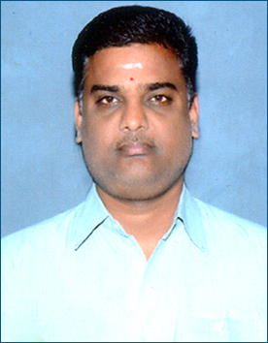Author of this article is Dr.Saravan kumar. He is a professional cost accountant associated with a multinational company in Hyderabad. He has also studied Astrology and Vastu sastra. He won a Ph**D award for his thesis on astrological study of reasons for delay in marriages. He is leading member of JKR astro research foundation, exhibiting flair of event management. He is also a popular teacher, Research Guide and a member of faculty at JKR astro research academy.*

Significator means the planet or planets responsible for giving the result of the house / houses wherever they are posited in the natal chart during their Dasa or Bhukti or Antara. We all know the significators for all the houses / bhavas. Significator for the First house is Sun, second house is Jupiter, third house is Mars, fourth house is Moon, fifth house is Jupiter, sixth house is Mars and Saturn, seventh house is Venus, eighth house is Saturn, ninth house is Sun and Jupiter, tenth house is Saturn, eleventh house Jupiter and Twelfth house is Saturn..Thus Significator is also known as karaka planet for a particular Bhava/house. The significators given above are as per the traditional Vedic astrology. The bhava lord and karaka will give the result of the bhava in their dasa, bhukti or in anthara. But sometimes the event will happen without the touch of significator or the bhava lord.

Meena2 Naadi system explains how to identify the real significator of a particular karakatwain giving the result for the particular bhava and karaka. Pujya Guruji Shri.N.V.Raghava Chary has given seven principles to identify the significator/s for a particular bhava and karaka.

The following 7 Meena2Naadi principles will help us to identify the significators of a particular bhava and karaka:

1. Bhava Lord or house lord
2. Planets posited in the star of bhava lord or house lord
3. Occupant of the Bhava or house
4. Planets posited in the star of bhava lord or house lord
5. Aspect on the bhava or house
6. Aspect on the Bhava lord or house lord
7. Conjunction of the bhava lord or house lord.

Let us identify the significators with one example chart for child birth.

5th house (house of children), 2nd house (house of family) and 11th house of (house of gains) and karaka Jupiter are to be seen for the event of child birth. As per Meena2Naadi, it is required to identify the significators for these houses and karaka.

**Example:**

The native gave birth to child on 02-10-2000 in the **Mercury** Dasa, **Rahu** bhukti and **Rahu** Anthara.

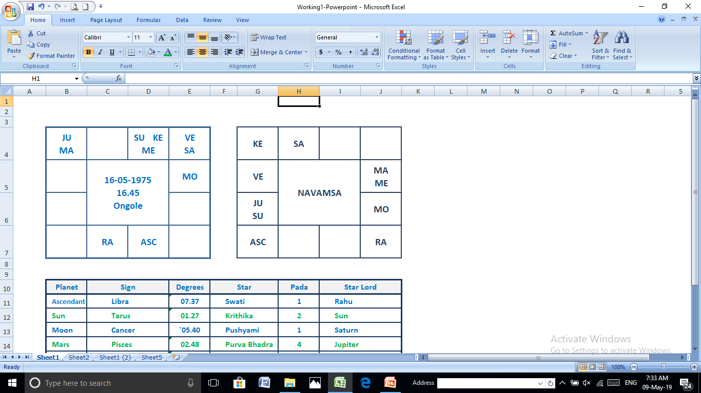

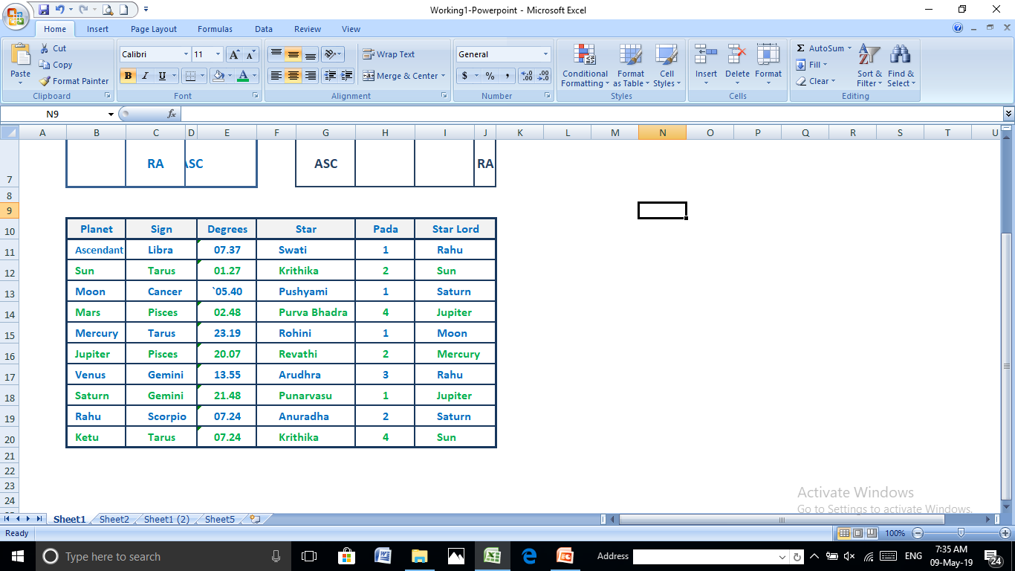

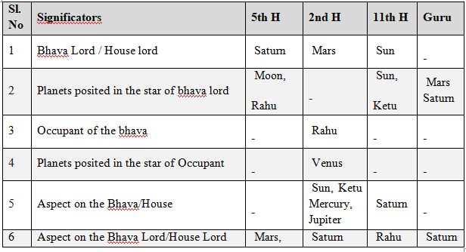

**Strength of the planets:**

**The number of times a particular planet appears in different columns of above chart are taken as strength of that planet**

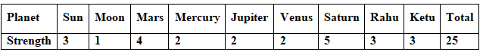

From the above, It can be seen in this chart, that all the plants are identified as significators for the 5th house and karaka. Saturn has got more strength and will play an important role in the time of event.

**Time of Event:**

Whenever all the significators gets connection with Dasa Lord or Bhukthi Lord or Anthara Lord in the transit, event will happen.

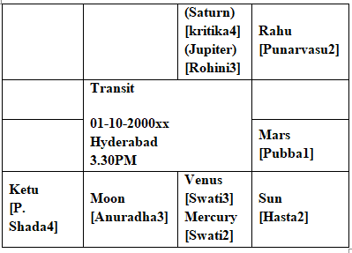

From the above, it can be seen in above transit chart of day that, all the significators are getting touch with Dasa lord or Bhukthi lord or anthara lord in the transit on the day of the event.

On the transit day, **Sun** is posited in the House of Mercury who is a Dasa lord. **Moon** is posited in Scorpio on the Natal Rahu who is a Bhukthi and Anthara Lord, **Mars** is posited in Leo and aspected by the Natal Saturn from Gemini, **Mercury** is posited In Libra in the star of Rahu who is a Bhukthi and Anthara lord, **Jupiter** is posited in the Tarus on the natal Mercury who is a Dasa lord, **Venus** is posited in Libra along with Dasa lord Mercury, **Saturn** is posited in Taurus on natal Mercury who is a Dasa Lord, Rahu is posited in Gemini which is a Dasa Lord **Mercury** house, Ketu is posited in Sagittarius and aspected by the Natal Saturn which is Sanivat Rahu.

Bhukthi and anthara lord Rahu will give the result of Saturn because of **Sanivath Rahu**. In the natal chart, 5th lord Saturn is aspecting karaka Jupiter and in the transit also Saturn is associated with Jupiter.

As per Meen2Naadi principle, during the event day, all the significators identified for the bhava and karaka of the 5th house are getting connection with Dasa lord and bhukthi lord and Anthara Lord in transit for happening of the event.

**//Om SreeGurubhyoNamah//**

**HIGHER EDUCATION**

***- Dr.R.Chandra Lekha***

*Dr.R.ChandraLekha is a faculty in JKR Astro Research Foundation. She pursued her Masters in Astrology from Potti Sreeramulu Telugu University and Masters in Vedanga Jyothisha and PhD from Yoga Samskrutham University, Florida USA under the guidance of Dr. NVRA. Raja. Presently she is pursuing her MSC Psychology from Dr. B.R. Ambedkar University. She is by Profession High School teacher and an Astro Consultant in Astro Yogi.*

|  |
| --- |
| **Author’s Note:**  **The topic that I chose to write about in astrology is Retrograde. Retrograde Motion is so radically different than the norm, it’s not a surprise that many people often experience it as disruptive. The question, then, is whether disruption is in an of itself a bad thing. So I chose the topic which will give some insight on other phase of Retrograde.** |

One of the wonderful assets given by Creator to human kind is the divine science of Astrology. It reduces and unfolds the uncertainties of life, and helps move in the right directions. The various aspects of human life is what astrology deals with; such as education, career, marriage, family, children, health, social status and finance etc.,

Retrograde is when a planet is moving backward in the Sky. In Traditional astrology, the retrograde planet is considered to be in the previous (Preceding) sign (Rashi). However, in Meena 2 Naadi System, Retrograde means moving back to previous star not sign. According to Meena2Naadi System, retrograde means planet is in movement towards its previous star. For example, if Jupiter (who is in Scorpio sign) is in Libra sign due to retrogression. In Meena2 system, it is taken that Jupiter is in Scorpio sign but in Anuradha star and is presumed to be in Vishaka star due to retrogression.

We can interpret the retrogrades of Venus, Mercury and Mars as being the most personal and most challanging and requiring the biggest adjustments. Jupiter and Saturn go retrograde more frequently, about a third of the time, and their loops and shapes are more flattened and less extreme.

**Successful Ortho – Surgeon**

**Male, Date of Birth: 20.03.1981, Time of Birth: 14.28 hrs,**

**Place of Birth: Hyderabad**

**India**

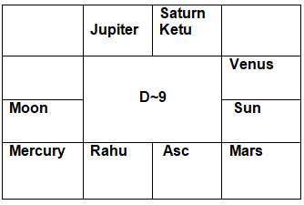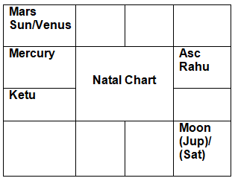

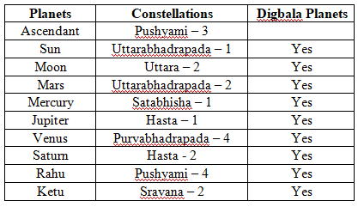

The native was a topper throughout his schooling. The native is an accomplished Ortho-Surgeon. He received Gold Medals both during his graduation and post-graduation. He hails from an affluent family and is leading a comfortable life.

Karaka for Medicine - Sun, Mars

Higher Education in the chart is seen through 5th house (use of Knowledge) and 9th house (higher education).

For Medical field

* 6th house (Service, diseases)
* 7th house (Patient)
* 8th house (diagnosing the disease, Longevity)
* 12th house (Hospitals, bed)
* Moon the karaka for mind
* Mercury the natural 6th lord
* 10th house of Profession (5th to 5th house)
* 11th house of Gains and
* Strong connection between 6th or 12th house either through SookshmaParivarthan or SthoolaParivarthan or conjunction or through aspect indicates profession related to medicine.

Analysis

* Lagna lord Moon is aspected by 4th lord Venus and attains digbala.
* 2nd Lord Sun is conjunct with 10th lord Mars and attains digbala.
* 3rd and 12th lord Mercury starlord Rahu is posited in Lagna and attains digbala.
* 4th and 11th lord Venus starlord Jupiter is aspected by 4th lord Venus and attains digbala.
* 5th and 10th lord Mars starlord Saturn is aspected by 10th lord Mars and attains digbala.
* 6th and 9th lord Jupiter starlord Moon is the lagnalord and attains digbala.
* 7th and 8th lord Saturn starlord Moon is conjunct with 7th lord Saturn and attains digbala.
* Rahu starlord Saturn is the 7th lord and attains digbala.
* Ketu starlord Moon is aspected by 10th lord Mars and attains digbala.
* Here, point to be noted is all the planets are attaining digbala.

The planet which are in Retrograde in this chart are Jupiter and Saturn.

* Jupiter is in the star of Hasta (Moon) and through Retrograde will also deliver the results of Previous star Uttara (Sun). Even if Jupiter is in Sun star, Jupiter is conjunct with lagnalord Moon and attains digbala. Jupiter lord of 6th house of Competition, service and one of the prime house for medicine and 9th house of yogakaraka for the native.
* Saturn is in the star of Hasta (Moon) and through Retrograde will also deliver the results of previous star Uttara (Sun). Even if Saturn is in Sun star, starlord Sun is aspected by 7th lord Saturn and attains digbala. Saturn lord of 7th house of Patients, opponents and lord of 8th house which is also one of the prime house for medicine.

For Medicine 6th, 8th, 12th houses or its star lord and karaka Sun connection is to be seen. The native during Mars dasa chosen his education field into Medicine. Dasa lord Mars the 5th house of intelligence, sign scorpio with deep interest to urge the subject and being 10th lord of profession getting powerful digbala is conjunct with Dhanvantri karaka Sun 2nd lord and exalted Venus lord of 4th house of basic education and 11th house of labha sthana gave the native excellence in Medical field. The native during graduation period was a gold medalist. If we carefully look Mars is in the star of Saturn getting good guna (TT) and star lord is in retrograde giving results of both Moon (Lagna lord) and Sun (2nd lord).

Mars star lord Saturn lord of 8th conjunct with 6th lord Jupiter and Saturn through retrograde gives results of Sun and through backward bhinnapada touches Leo and aspects 12th lord Mercury.

The Next dasa of the native is Rahu and it has got powerful digbala. According to our Param Pujya Guruji, Rahu representation gives the results of Sign lord, star lord, aspect, association and conjunction. Rahu is in the star of Saturn and star lord Saturn gives results of Moon and Sun through retrograde. Rahu delivers the results of House lord Moon.

The present dasa of the native is Jupiter a yogakaraka and it has got strong digbala through lagna lord Moon conjunction. Jupiter lord of 6th house is conjunct with 8th lord Saturn and Jupiter through retrograde gave the results of Moon and Sun. Through Retrograde and backward bhinnapada Jupiter touches Leo sign and aspects 3rd and 12th lord Mercury.

A strong retrograde planets Saturn and Jupiter through its star lord Moon and karaka for Medicine Sun (name and fame) with strong digbala has given the native a successful Medical Profession as Ortho-Surgeon.

Jai Meena2

**LIST OF JKR ASTRO RESEARCH FOUNDATION, HYDERABAD PUBLICATIONS**

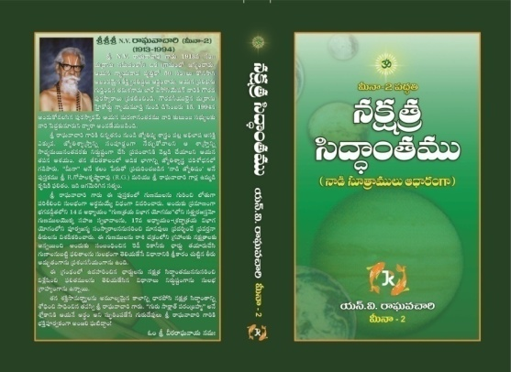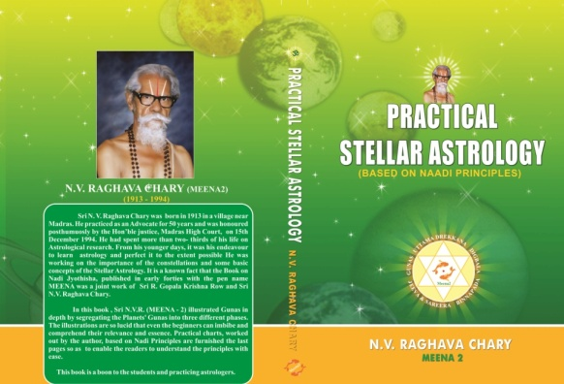

**Price: Rs 225/-**

**Special Price* to Students: Rs 200/-**

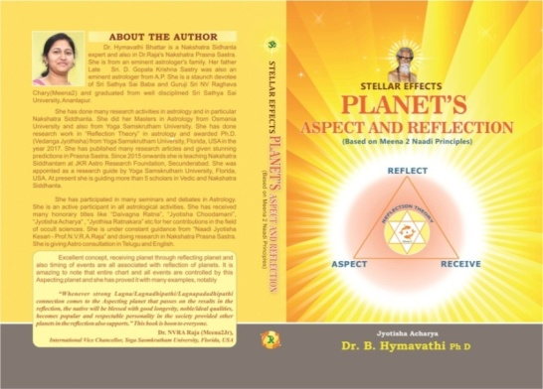

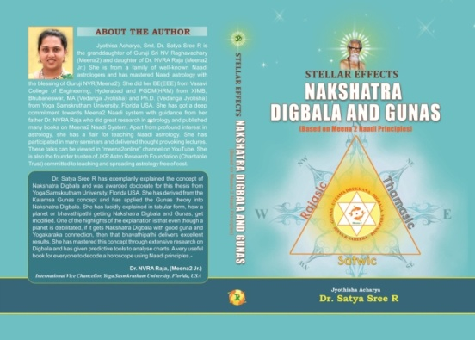

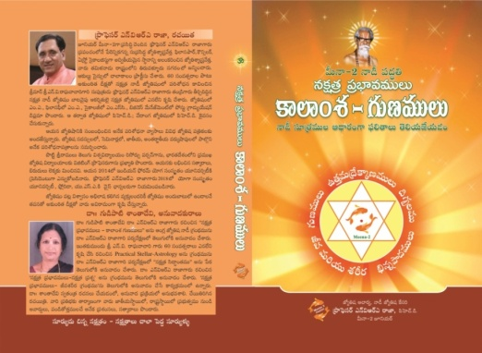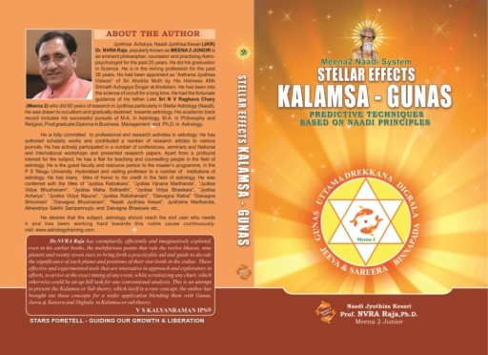

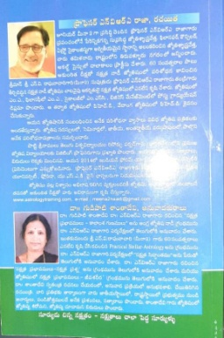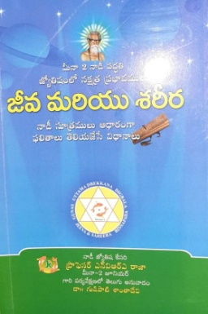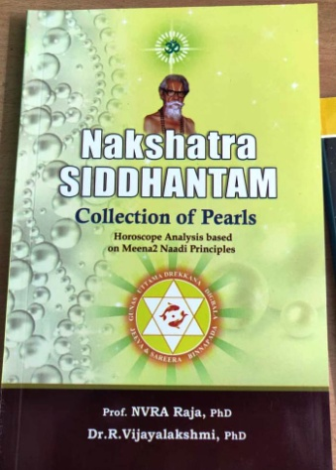

1. Practical stellar Astrology by .N.V.Raghavacharygaru Second revised edition 2004
2. Page no: 331 JeevaSareera by Dr.N.V.R.A. Raja first edition 2009
3. Page no: 323 JeevaSareera by Dr.N.V.R.A. Raja first edition 2009
4. Page no: 278 First edition 2019 NakshatraDigbalas and Gunas by : Dr.Satyasree R (Grand daughter of N.V.Raghavacharygaru )
5. Page no: 238First edition 2019 Planets Aspect and reflection by Dr.B.Hymavathi
6. Page no: 188 Second edition 2013 Stellar effects KALAMSA GUNAS By: Prof.NVRA Raja
7. Page no: 126 2016 EDITION NakshatrasiddhanthamBtProf.NVRA Raja &Dr.Vijayalakshmi
8. PSA Page no: 167 second edition / page no: 113 Article 18 Matching of horoscopes byNakshatrasiddhanthamBtProf.NVRA Raja &Dr.Vijayalakshmi.
9. Class room notes by Prof.NVRA .Raja.
10. Class room notes by Prof.NVRA .Raja
11. You tube talk by Dr.NVRA Raja on Marriage matching @6.30 PM JULY 2020